Supplemental Materials
Supplemental Figure 1. There is no significant relationship between circulating CFH and plasma (A) chondroitin sulfate or (B) hyaluronic acid. N = 10 for CFH < 10 mg/dL, N = 16 for CFH 10-19 mg/dL, N = 15 for CFH 20-39 mg/dL, N = 23 for CFH ≥ 40 mg/dL. Data are presented as median ± IQR. Males are represented as circular symbols and females are depicted as squares. Comparisons were made by Jonckheere-Terpstra test for trend. CFH, cell-free hemoglobin.

Supplemental Figure 2. Cell-free hemoglobin does not affect heparanase (A) transcription or (B) protein levels. N = 4-18 per group. Timepoint: 24 hours. Data are presented as box-and-whisker plots, with boxes representing the interquartile range and the horizontal line representing the median, whiskers extending from minimum to maximum values, and all individual data points shown. Male donors are represented as circular symbols and female donors are depicted as squares. Comparisons were made by Mann-Whitney test. CFH, cell-free hemoglobin; RE, relative expression.
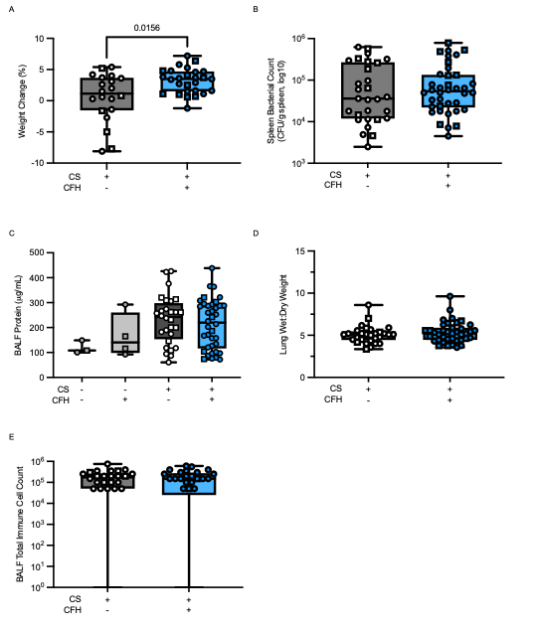
Supplemental Figure 3. (A) Septic mice treated with CFH gained significantly more weight over 24 hours. The addition of CFH to murine polymicrobial peritoneal sepsis does not impact (B) spleen bacterial counts, (C) BALF protein levels, (D) lung weight-to-dry weight ratios, or (E) BALF total immune cell counts. N = 3-51 per group. Timepoint: 24 hours post-sepsis induction. Data are presented as box-and-whisker plots, with boxes representing the interquartile range and the horizontal line representing the median, whiskers extending from minimum to maximum values, and all individual data points shown. Male mice are represented as circular symbols and female animals are depicted as squares. Comparisons were made by Mann-Whitney test (A-B, D-E) or Kruskal-Wallis test (C). CS, cecal slurry; CFH, cell-free hemoglobin; BALF, bronchoalveolar lavage fluid.

Supplemental Figure 4. There were no significant differences in (A) weight change over 24 hours, (B) spleen bacterial counts, (C) BALF protein levels, or (D) lung wet-to-dry weight ratios between Hpse^{ΔEndo} animals and their WT counterparts. N = 8-10 per group. Timepoint: 24 hours post-sepsis induction. Data are presented as box-and-whisker plots, with boxes representing the interquartile range and the horizontal line representing the median, whiskers extending from minimum to maximum values, and all individual data points shown. Male mice are represented as circular symbols and female animals are depicted as squares. Comparisons were made by Mann-Whitney test. WT, wildtye; Hpse^{ΔEndo}, endothelial-specific deletion of heparanase; BALF, bronchoalveolar lavage fluid.

Supplemental Figure 5. There were no significant differences in (A) weight change over 24 hours, (B) spleen bacterial counts, (C) BALF protein levels, or (D) lung wet-to-dry weight ratios between acetaminophen (APAP)-treated animals and their counterpart controls. N = 7-17 per group. Timepoint: 24 hours post-sepsis induction. Data are presented as box-and-whisker plots, with boxes representing the interquartile range and the horizontal line representing the median, whiskers extending from minimum to maximum values, and all individual data points shown. Male mice are represented as circular symbols and female animals are depicted as squares. Comparisons were made by Mann-Whitney test. CS, cecal slurry; CFH, cell-free hemoglobin; APAP, acetaminophen; BALF, bronchoalveolar lavage fluid.

Target | Primer ID | Catalog Number | Manufacturer
GAPDH | Mm99999915 | 4331182 | Thermo Fisher Scientific
TNF-α | Mm00443258 | 4331182 | Thermo Fisher Scientific
IL-6 | Mm00446190 | 4331182 | Thermo Fisher Scientific
CXCL1 | Mm04207460 | 4331182 | Thermo Fisher Scientific
IFN-γ | Mm01168134 | 4331182 | Thermo Fisher Scientific

Supplemental Table 1. Primer information for whole lung proinflammatory cytokine mRNA quantification. GAPDH, glyceraldehyde-3-phosphate dehydrogenase; TNF-α, tumor necrosis factor-alpha; IL-6, interleukin-6; CXCL1, chemokine (C-X-C motif) ligant 1; IFN-γ, interferon-gamma.

Target | Primer ID | Catalog Number | Manufacturer
GAPDH | Mm99999915 | 4331182 | Thermo Fisher Scientific
NGAL | Mm01324470 | 4331182 | Thermo Fisher Scientific
KIM-1 | Mm00506686 | 4331182 | Thermo Fisher Scientific

Supplemental Table 2. Primer information for whole lung proinflammatory cytokine mRNA quantification. GAPDH, glyceraldehyde-3-phosphate dehydrogenase; NGAL, neutrophil gelatinase-associated lipocalin; KIM-1, kidney injury molecule-1.

