Supplemental Figures and Legends

Supplemental Figure 1. Antibody deficiency enhances metastatic phenotypes in KC-μSAID pancreata. (A) Levels of Ig isotype antibodies in blood of 5-month-old Pdx1-Cre WT, KC-WT, and KC-μSAID mice based on ELISA, n = 5 - 15 mice/genotype, mean +/- SD, **P < 0.01, ****P < 0.0001; 2-way ANOVA with Tukey’s multiple comparison test. (B) Levels of Ig isotype antibodies in peripheral blood of 5-month-old Pdx1-Cre;53^{FL/+} WT, KPC-WT, KPC-μSAID mice, n = 5 - 15 mice/genotype, mean +/- SD, ***P < 0.001; 2-way ANOVA with Tukey’s multiple comparison test. (C) Left panel: Low magnification images of pancreas from 5-month-old KC-WT (top) and KC-μSAID mice. The extent of pancreas pathology was evaluated in a semi-quantitative, blinded manner by a board-certified veterinary anatomic pathologist (JBF). Right: The % normal and affected regions of pancreas from KC-WT (n = 13) and KC-μSAID (n = 21) mice, mean +/- SD, ***P < 0.001; Welch’s t test. (D) Pancreas weights in 10-month-old KC-WT (n = 7) and KC-μSAID mice (n = 6), mean +/- SD, *P < 0.05; Welch’s t test. (E) Left panel: Kaplan-Meier survival curve of KC-WT and KC-μSAID mice, n = 11 - 16 mice/genotype. *P < 0.05; log-rank test. Right panel: Assessment of % affected pancreas in available H+E-stained specimens from 10-month-old KC-WT (n = 3) and KC-μSAID (n = 5) mice. *P < 0.05; Welch’s t test. (F) Pancreas weights in 3-month-old KPC-WT (n = 44) and KPC-μSAID mice (n = 29). Data is represented as mean +/- SD, **P < 0.01; Welch’s t test. (G) Representative IHC for CK17/19 and Vimentin in adenocarcinoma and (H) sarcomatoid carcinoma of the pancreas in KPC mice. (I-J) The extent of vascular (I) and perineural (J) invasion was examined in 12-week-old KPC-WT and KPC-μSAID mice. *Is indicative of region of tumor cell invasion (K) Vascular permeability was evaluated by IV injection of 1 mg of FITC-dextran (2,000 kDa) in KPC-WT (n = 3) and KPC-μSAID (n = 3) mice. FITC-dextran (green), CD31 (red), and EpCAM (blue) are represented in the images on the left panel. The ratio of % FITC-dextran: % CD31 area is graphed in the right panel, mean +/- SD, ns = non-significant; Welch’s t test. (L) The area of CD31⁺ vascular staining was determined in neoplastic regions in KPC-WT and KPC-μSAID mice, ns = non-significant; Welch’s t test.

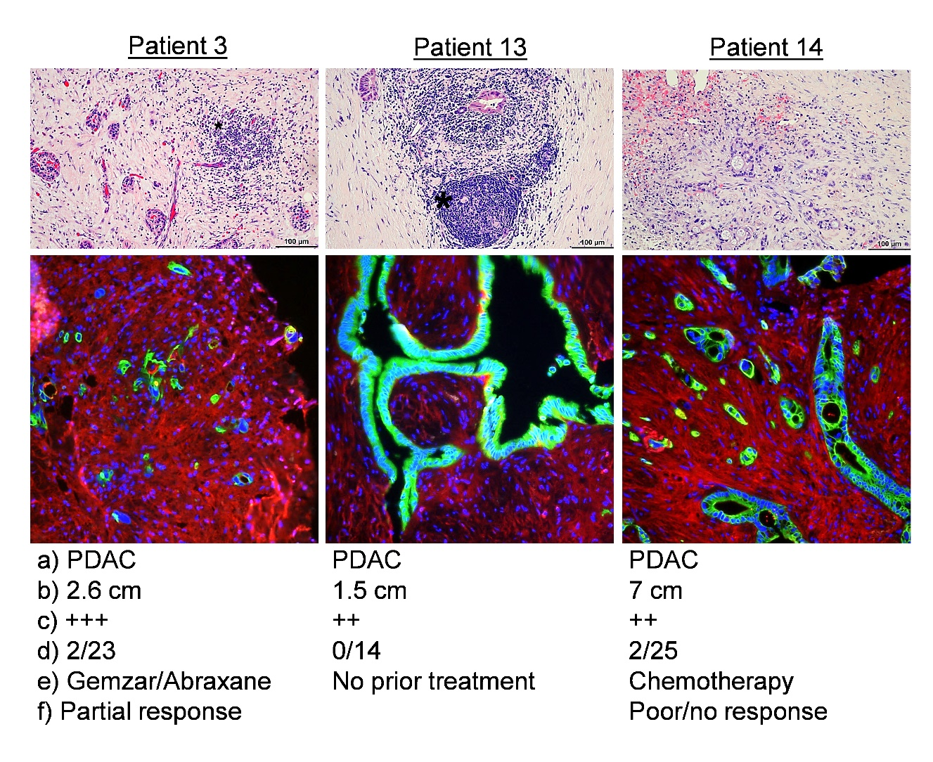
Supplemental Figure 2. IgG and IgM binding to tumor epithelium in human PDAC patient samples. Representative H+E (top panel) and immunofluorescent images of human PDAC tumor tissue stained with goat anti-human IgG-AF555, rat anti-human CK7-AF488, and DAPI [(a) diagnoses, (b) tumor size, (c) extent of ECM deposition, (d) number of lymph nodes containing tumor, (e) treatment prior to surgical resection, and (f) patient response to treatment are indicated below IF images]. TLS location noted in patient 13 H+E noted adjacent to asterisk.

Supplemental Figure 3. IgG deposition and FcγR expression on stromal and myeloid cells in the pancreatic microenvironment. (A) Cell gating scheme for CD45+ subsets including CD45+Ly6C-F4/80-, CD45+Ly6CintF4/80-(gMDSC), CD45+Ly6ChiF4/80int (mMDSC), CD45+Ly6CloF4/80+ (macrophage), CD45-EpCAM+ epithelia, and CD45-EPCAM- mesenchymal cells including CD31+ endothelium and CD31- Podoplanin+ CAFs. (B) Representative staggered histograms depicting FcγR1 (CD64), FcγR2b (CD32), and FcγR3 (CD16) on the afore-mentioned subsets in panel A. (C) Right panel: Representative IF images of IgG and podoplanin expression. Left panel: The % colorimetric overlap for IgG proximal to podoplanin⁺ cells was quantified in antibody-sufficient, KC-WT and KPC-WT mice (n = 4 - 5 mice/group), mean +/- SD, ns = non-significant; Welch’s t test. (D) Right panel: Representative IF images of IgG and F4/80 expression. Left panel: The % colorimetric overlap for IgG proximal to F/480⁺ cells was quantified in antibody-sufficient, KC-WT and KPC-WT mice (n = 4 mice/group), mean +/- SD, ns = non-significant; Welch’s t test.

Supplemental Figure 4. Multiparameter flow cytometric analysis of dendritic cell subsets isolated from the pancreas of perfused mice. (A) Identification of dendritic cell subsets in the CD11b+/-F4/80-Gr-1- subset using MHCII and CD11c followed by XCR1 (cDC1) and CD172α (cDC2). (B-C) Percentages of tumor-infiltrating CD11b-CD172α-XCR1+ cDC1 (B), and CD11b+CD172α+ cDC2 (C), in 12-week-old KPC-WT vs. KPC-μSAID TME (n = 15 - 20 mice/group), mean +/- SEM, ns = non-significant; Welch’s t test.

Supplemental Table 1. Immunohistochemistry Primary Antibodies
Antigen | Clone | Vendor | Antigen Retrieval | Dilution | RRID #
CD3 | CD3-12; rat IgG1 | Abcam | TRIS-EDTA pH 9 | 1/400 | AB_2889189
CD4 | 4SM95; rat IgG1 | Invitrogen | TRIS-EDTA pH 9 | 1/400 | AB_2573008
CD8 | 4SM16; rat IgG2a | Invitrogen | TRIS-EDTA pH 9 | 1/400 | AB_2637159
Foxp3 | FJK-16s; rat IgG2a | Invitrogen | Citrate pH 6 | 1/200 | AB_467576
F4/80 | CI:A3-1; rat IgG2b | BioRad | Citrate pH 6 | 1/400 | AB_323279
MPO | 2D4; Mouse IgG1 | Abcam | Citrate pH 6 | 1/400 | AB_2050022
B220 | RA3-6B2; rat IgG2a | BD | Citrate pH 6 | 1/200 | AB_394614
Keratin 17/19 | D32D9; rabbit mAb | Cell Signal | Citrate pH 6 | 1/1000 | AB_2797912
Podoplanin | Pmab-1;rat IgG2a | BioLegend | n/a | 1/200 | AB_2750408
CD326 | G8.8;rat IgG2a | BioLegend | n/a | 1/200 | AB_1134099
IgA | Polyclonal | SBA | n/a | 1/500 | AB_2794378
IgG | Polyclonal | SBA | n/a | 1/2000 | AB_2794359
IgM | Polyclonal | SBA;1020-32 | n/a | 1/500 | AB_2794223
F4/80 | BM8 | BioLegend | n/a | 1/200 | AB_893480
CD31 | 390 | BioLegend | n/a | 1/200 | AB_312903
Supplemental Table 2. FACS Antibody List
Antibody | Supplier | Clone | Dilution | Cat | RRID
NK 1.1 FITC | BioLegend | PK136 | 1-100 | 108705 | AB_313392
PD-1 FITC | BioLegend | 29F.1A12 | 1-200 | 135214 | AB_10680238
CD45 PE | BD | 30-F11 | 1-800 | 561087 | AB_394611
F4/80 PE | BioLegend | BM8 | 1-800 | 123110 | AB_893486
TNFα PE | BioLegend | MP6-XT22 | 1-200 | 517008 | AB_315426
Gr-1 PE Cy7 | BioLegend | RB6-8C5 | 1-1000 | 108416 | AB_313380
Granzyme B PE Cy7 | BioLegend | GB11 | 5 uL/10 cells | 372214 | AB_2728380
Ly6C PE Cy7 | BioLegend | HK1.4 | 1-3000 | 128017 | AB_1732082
CD8 PE Cy7 | BioLegend | 53-7.3 | 1-400 | 100622 | AB_2562772
CD11b PE 594 | BioLegend | M1/70 | 1-3000 | 101255 | AB_2563647
IFNγ PE 594 | BioLegend | XMG1.2 | 1-1000 | 505846 | AB_2563979
CD45 PerCP | BioLegend | 30-F11 | 1-800 | 103130 | AB_893339
TCRγδ PerCP  Cy 5.5 | BioLegend | GL3 | 1-200 | 118117 | AB_10612572
Foxp3 APC | Invitrogen | FJK-16s | 1-200 | 17-5773-82 | AB_469457
CD11c APC | BioLegend | N418 | 1-400 | 117309 | AB_313778
CD172α Alexa  Flour 700 | BioLegend | P84 | 1-1000 | 144022 | AB_2650812
CD62L APC Cy7 | BioLegend | MEL-14 | 1-800 | 104428 | AB_830798
Podoplanin APC Cy7 | BioLegend | 8.1.1 | 1-200 | 127418 | AB_2629804
XCR1 BV 421 | BioLegend | ZET | 1-1000 | 148216 | AB_2565230
CD11b Pacific Blue | BioLegend | M1/70 | 1-1000 | 101224 | AB_755985
Live Dead Aqua | Invitrogen | n/a | 1-500 | L34966
PD-L1 BV605 | BioLegend | MIH5 | 1-400 | 153606 | AB_2814056
MHCII BV 650 | BioLegend | M5/114/15.2 | 1-800 | 107641 | AB_2565975
CD4 BV 650 | BioLegend | GK1.5 | 1-800 | 100469 | AB_2783035
CD31 BV785 | BioLegend | 390 | 1-800 | 102435 | AB_2810334
CD44 BUV73 7 | BD | IM7 | 1-800 | 612799 | AB 2870126
Fc Block  CD16/CD32 | BioLegend | 93 | 1-500 | 101320 | AB 10766423

