SUPPLEMENTAL MATERIAL: Consideration of spatial companion biomarkers for targeted therapeutics in cancer: depatuxizumab mafodotin in glioblastoma

Sex as a biological variable.
Both male (n=20) and female (n=9) patients were included in this study. The distribution observed in our study is in line with what would be expected. There is a slightly higher incidence of glioblastoma in men compared to women.

Statistics overview.
Kaplan-Meier method was used to develop curves for overall survival (OS) and progression free survival (PFS). A scatter plot was used to analyze the relationship between perivascular EGFR+ tumor cells and PFS.

Study approval.
This study was approved by the Northwestern University Institutional Review Board (IRB).

Data Availability.
This human subject data is not publicly available. This data may be made available in anonymized fashion upon request and within the context of an IRB approved protocol.

- Summarized inclusion criteria.
Inclusion criteria: ≥18 years old, EGFR amplification or EGFRvIII mutation, stable/decreasing steroids, absolute neutrophils ≥1,500/mm³, platelets ≥75,000/mm³, (≥100,000/mm³ with temozolomide), and hemoglobin ≥9.0 gm/dL. Patients who were pregnant, had severe hepatic impairment, or had an infection were excluded. Patients underwent pre-treatment ophthalmologic assessment, and then, as indicated.

- Expanded Access Protocol.

- Demographic and clinical characteristics.
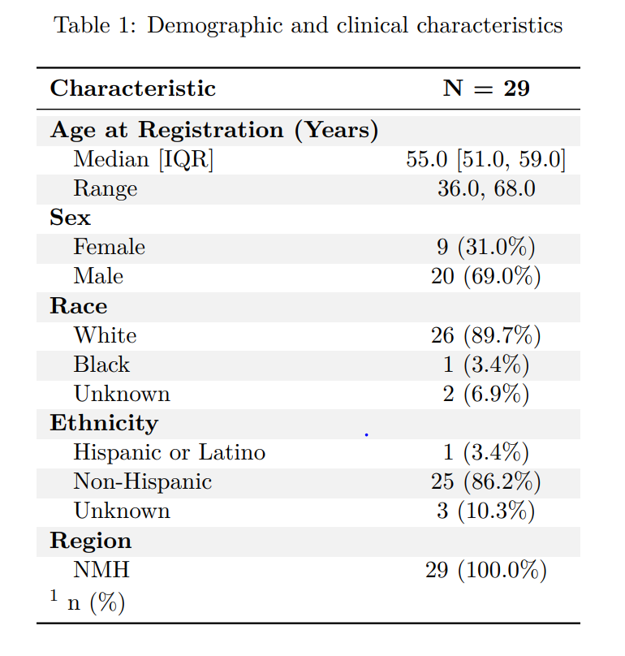

- Progression free survival (PFS).
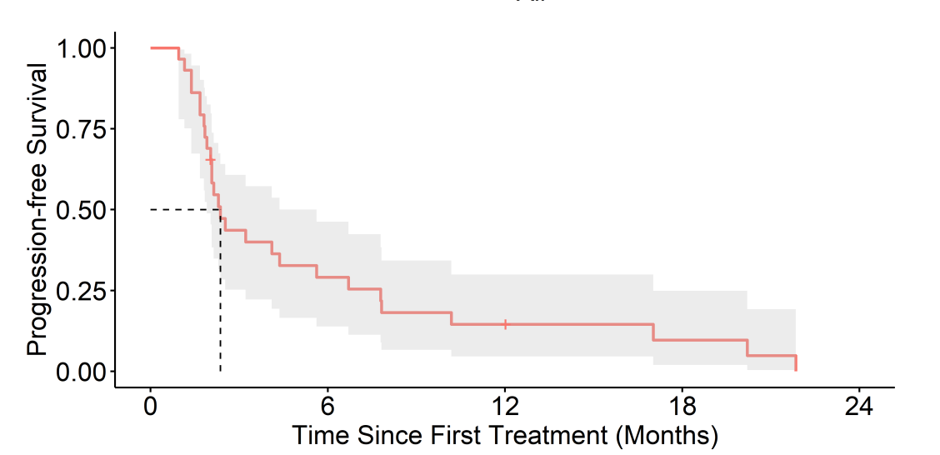

- Percentage of perivascular EGFR+ cells and progression free survival (PFS).
Scatter plot depicting percent of EGFR+ cells within perivascular regions (40 µm boundary) and corresponding PFS. Blue line represents line of best fit with summary statistics provided.

