Figure legend:
Supplemental Figure 1. Purity of donor and host monocytes from patient PB collected 2 years post-BMT and purified using FACS sorting. A) Gating strategy for donor and host monocytes before sorting, A1, CD14+monocyte selection; A2. singlet selection; A3. Separation of donor and host monocyte based on donor HLA-specific Ab. B) Purity of isolated donor monocytes. B1. CD14+monocytes; B2. Singlet selection; B3. purity of isolated donor monocytes after sorting. C) Purity of isolated host monocytes. C1. CD14+monocytes; C2. Singlet selection. C3. purity of host monocytes after sorting.
Supplemental Table 1. Patient chimerism post-BMT (% donor)
Supplemental Table 2. Reconstitution of immune components post-BMT prior to and during thymopoiesis (cell numbers/µL by research FC).
Supplemental Table 3. Potential outcomes and mechanistic interpretation of Tolerance in different MLR set ups
Supplemental Table 4. Clinical chronology and graft characteristics
Supplemental Table 5. List of genes and their ranks in the downregulated ‘Allograft Rejection’ pathway analyzed by GSEA software, contrasting tolerant T cells (Tol T) and graft T cells (gT)¹ after in vitro stimulation with hDC.
Supplemental Table 6. Signaling pathway profile analyzed by GSEA software comparing tolerant T cells (2 years post-BMT) and graft T cells after in vitro stimulation with hDCs.
Supplemental Table 7. Signaling pathway profiles analyzed by IPA software contrasting circulating donor-derived tolerant T cells (Tol T, 2 years post-BMT) and donor bone marrow graft T cells (gT) after in vitro stimulation with hDCs.
Supplemental Table 8. Signaling pathway profiles analyzed by IPA software contrasting tolerant T cells (Tol T, 2 years post-BMT) and bone marrow graft T cells (gT) without any in vitro stimulation.
Supplemental Table 9. Signaling pathway profiles analyzed by IPA software contrasting co-existing circulating host and donor monocytes at 2 years post-BMT.

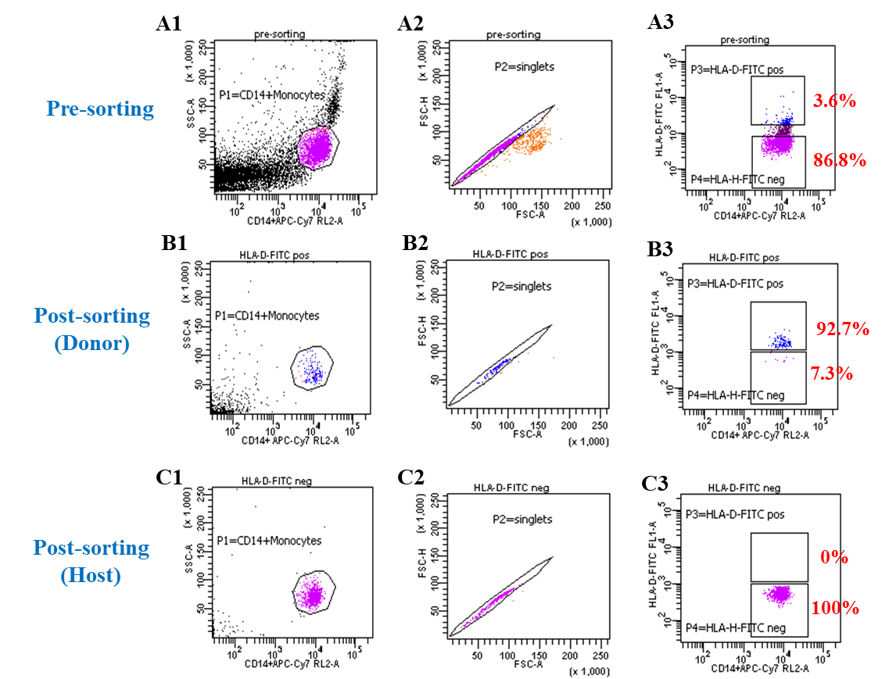
Supplemental Figure 1. Purity of donor and host monocytes from patient PB collected 2 years post-BMT and purified using FACS sorting. A) Gating strategy for donor and host monocytes before sorting, A1, CD14+monocyte selection; A2. singlet selection; A3. Separation of donor and host monocyte based on donor HLA-specific Ab. B) Purity of isolated donor monocytes. B1. CD14+monocytes; B2. Singlet selection; B3. purity of isolated donor monocytes after sorting. C) Purity of isolated host monocytes. C1. CD14+monocytes; C2. Singlet selection. C3. purity of host monocytes after sorting.

Supplemental Table 1. Patient chimerism post-BMT (% donor)

Chimerism | Post-BOLT/ pre-BMT | 1m  Post-BMT | 2m | 3m | 6m | 9m | 1yr | 1yr6m | 2yrs | 3yrs | 4yrs | 5yrs | 6yrs | 7yrs6m | 9yrs6m
STR¹
PB | 0 | 100 | 72 | 52 | 24 | 21 | 26 | 30 | 28 | 22 | 23 | 17 | 22 | 20 | 21
CD3+T cells | N/A | N/A | 27 | N/A | 94 | 93 | 100 | 95 | 97 | 93 | 92 | 89 | 96 | 96 | 96
CD33+ Myeloid cells | N/A | 100 | 71 | 46 | 17 | 15 | 16 | 14 | 12 | 9 | 9 | 8 | 9 | 8 | 7
CD19+ B cells |  |  |  |  |  |  |  |  |  |  | 69 | 62 | 28 | 39 | 38
FC² PB
CD3+T cells | N/A | N/A | 8.6 | 99.2 | 99.3 | 99.8 | 99.8 | 99.8 | 99.8 | 96.6 | 95.4 | 98.9 | 99.8 | 99.5 | 99.9
Monocyte (Myeloid) | N/A | N/A | 58 | 40 | 22 | 19 | 17.2 | 13.5 | 10.6 | 13.1 | 13 | 7.2 | 11.3 | 7.2 | 6.3
NK cells | N/A | N/A | 98 | 93 | 58 | 21 | 17 | 14 | 4.2 | 6 | 3.6 | 3.3 | 7.3 | 4 | 2.2
CD19+ B cells | N/A | N/A | N/A | N/A | N/A | 95 | 94.3 | 91 | 86.8 | 69 | 81.4 | 78.7 | 66.7 | 61.6 | 42.6
FC² BAL
CD3+T cells | N/A | N/A | N/A | N/A | 99.4 | 99.4 | 99.2 | 97.2 | N/A | N/A | N/A | N/A | N/A | N/A | N/A
Monocyte (Myeloid) | N/A | N/A | N/A | N/A | 42 | 34.5 | 24 | 24 | N/A | N/A | N/A | N/A | N/A | N/A | N/A
NK cells | N/A | N/A | N/A | N/A | 93 | 93 | 40 | 36 | N/A | N/A | N/A | N/A | N/A | N/A | N/A
CD19+ B cells | N/A | N/A | N/A | N/A | N/A | N/A | 63 | 46 | N/A | N/A | N/A | N/A | N/A | N/A | N/A
¹Short Tandem Repeat (STR) testing in the clinical UPMC HLA-laboratory performed on MiniMACS™ purified populations. (There was only 1 test that could be conducted for each assay, and no SD was displayed).
²Flow Cytometry (FC) in research laboratory. (There was only 1 test that could be conducted for each assay, and no SD was displayed).

Supplemental Table 2. Reconstitution of immune components post-BMT prior to and during thymopoiesis (cell numbers/µL by research FC)
Immune components | Baseline | Post-BLOT/ pre-BMT | 1m | 2m | 3m | 6m | 9m | 1yr | 1yr6m | 2yrs | 3yrs | 4yrs | 5yrs | 6yrs | 7yrs6m | 9yrs6m
CD3+T cells | 74 | 176 | 21 | 2.4 | 119 | 406 | 644 | 978 | 955 | 959 | 917 | 859 | 886 | 976 | 655 | 1334
CD4+T cells | 30 | 25 | 16 | 2 | 98 | 361 | 541 | 753 | 716 | 676 | 628 | 574 | 634 | 646 | 430 | 912
CD4+FOXP3+Treg | N/A | 2 | N/A | N/A | 1.5 | 5 | 1 | 6 | 4.4 | 22 | 4.7 | 8 | N/A | 25 | N/A | N/A
CD4+Tcon¹ | N/A | 22 | N/A | N/A | 90 | 321 | 487 | 642 | 619 | 564 | 596 | 509 | N/A | 445 | N/A | N/A
CD4+FOXP3+Treg/Tcon | N/A | 0.08 | N/A | N/A | 0.02 | 0.02 | 0.002 | 0.01 | 0.01 | 0.04 | 0.01 | 0.02 | N/A | 0.06 | N/A | N/A
CD4+T_{EM}² | N/A | 11 | N/A | N/A | 16 | 81 | 129 | 192 | 234 | 129 | 82 | 194 | 62 | N/A | N/A | N/A
CD4+T_{CM}³ | N/A | 14 | N/A | N/A | 80 | 250 | 306 | 390 | 152 | 256 | 255 | 188 | 251 | N/A | N/A | N/A
CD4+Tnaive | N/A | 0.4 | 0 | 0 | 2 | 25 | 88 | 159 | 269 | 276 | 277 | 237 | 222 | 233 | 168 | 374
CD8+T cells | 24 | 98 | 2 | 0.4 | 19 | 39 | 86 | 187 | 203 | 249 | 236 | 237 | 213 | 280 | 194 | 386
CD8+T_{EM}⁴ | N/A | 46 | N/A | N/A | 7 | 7 | 5.4 | 28 | 19 | 14 | 12.5 | 29 | 21 | N/A | N/A | N/A
CD8+T_{CM}⁵ | N/A | 28 | N/A | N/A | 11 | 5 | 11 | 35 | 3.4 | 14 | 16 | 5 | 25 | N/A | N/A | N/A
γδT cells | N/A | N/A | N/A | N/A | N/A | 3 | 3 | 5 | 6 | 5 | 9 | 11 | 7 | N/A | N/A | N/A
NK T cells | 1 | 0.4 | 1.4 | 0 | 0.1 | 0.5 | 2 | 2 | 5 | 5 | 6.7 | 7.5 | 17 | 6.5 | 1.3 | 1.3
NK cells | 227 | 308 | 173 | 149 | 92 | 208 | 159 | 373 | 215 | 240 | 211 | 173 | 291 | 268 | 211 | 417
CD19+ B cells | 1 | 34 | 3 | 0.5 | 0.2 | 4 | 88 | 102 | 177 | 221 | 341 | 232 | 216 | 200 | 160 | 198
Monocytes | 352 | 259 | 635 | 378 | 253 | 375 | 243 | 342 | 232 | 231 | 146 | 206 | 327 | 205 | 92 | 17.4
pDC⁶ | 6 | 24 | 35 | 7 | 6 | 11 | 7 | 4 | 13 | 7 | 11.6 | 8.8 | 10 | 9.7 | 9 | 7.7
mDC⁷ | 12 | 26 | 64 | 24 | 14 | 20 | 13 | 10 | 23 | 25 | 14.6 | 27 | 28.8 | 12 | 10 | 22
sjTREC⁸ | N/A | 369 | 0 | 0 | 0 | 677 | 1601 | 4486 | 1816 | 2085 | N/A | N/A | N/A | N/A | N/A | N/A
TCRB SCS⁹ | N/A | 136 | 48 | 85 | 132 | 170 | 137 | 160 | 159 | 155 | N/A | N/A | N/A | N/A | N/A | N/A
¹CD4+ Tcon = CD4+ conventional T cells (CD3+CD4+CD127+CD25+/-). ²CD4+ T_{EM}=CD4+ effector memory T cells (CD3+CD4+CD45RO+CD62L-). ³CD4+ T_{CM}=CD4+central memory T cells (CD3+CD4+CD45RO+CD62L+). ⁴CD8+ T_{EM}=CD8+effector memory T cells (CD3+CD8+CD45RO+CD62L-). ⁵CD8+ T_{CM}=CD8+central memory T cells (CD3+CD8+CD45RO+CD62L+). ⁶pDC=plasmacytoid dendritic cells. ⁷mDC=myeloid dendritic cells. ⁸sjTREC value = copies/1E+05 T cells; ⁹TCRB SCS = TCRβ spectratype complexity score, maximum SCS for 23 of Vβ tested = 184. (There was only 1 test that could be conducted for each assay, and no SD was displayed).

Supplemental Table 3. Potential outcomes and mechanistic interpretation of Tolerance in different MLR set ups.
Possible mechanisms | Clonal deletion | Suppression by Treg | Anergy | Suppression by Tr1
In vitro manipulation | ― | IL-2 IT* | IL-2 | Anti IL-10R Ab
Proliferation in MLR | -- | ↑ | ↑ | ↑
Cytokine  Profiling in MLR Supe | -- | ↑ Th1, Th2, Th17 | ↑ Th1, Th2, Th17 | ↑IL-10
TCR  Immunosequencing | Absent host-reactive clones | Representation of host-reactive clones | Representation of host-reactive clones | Representation of host-reactive clones
*IL-2-IT = IL-2-immunotoxin conjugate (Ontak™)

Supplemental Table 4. Clinical chronology and graft characteristics

Characteristics | Pt information
Disease | SCID (IL-7R)
Gender | Female
Age at BMT (years) | 14
HLA-match (serological) | 2/6
HLA-match (allele level) | 1/8
Lung Tx date | 9-25-2015
BMT date | 1-28-2016
BMT CD34+ Nº/kg | 5E+06
BMT CD3+ Nº/kg | 8E+04
DLI date | 4-5-2016
DLI CD3 Nº/kg | 5E+04
Stoppage date of FK506 | 5-5-2017
GvHD | Grade I, skin
Viral Infection | BKV

Supplemental Table 5. List of genes and their ranks in the downregulated ‘Allograft Rejection’ pathway analyzed by GSEA software contrasting tolerant T cells (Tol T) and graft T cells (gT)¹ after in vitro stimulation with hDC.

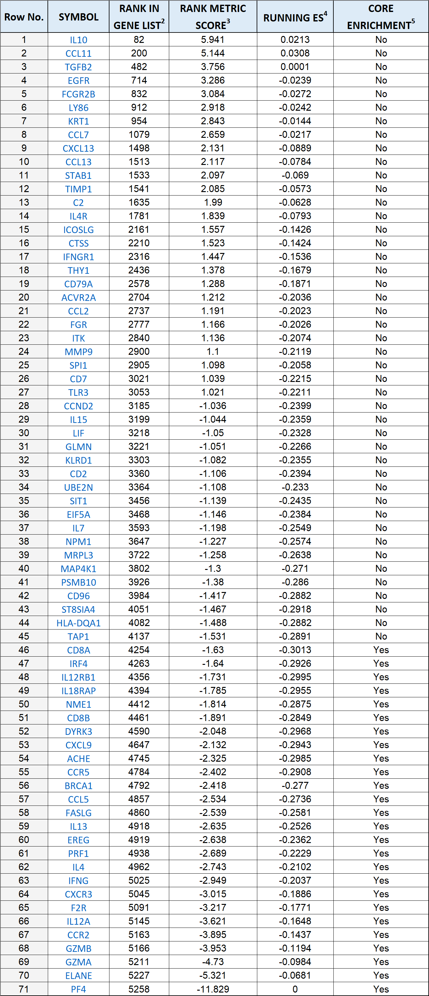

¹The gT stimulated with hDC was used as a control in the comparison.
²Rank in gene list: gene rank in gene list based on their differential expression.
³Rank metric score: the value assigned to each gene in a ranked list, which determines its position within the list and is used to assess how significantly a gene is differentially expressed based on GSEA default metric (signal-to-noise ratio). The higher scores indicate genes that are more significantly differentially expressed (GSEA user guide).
⁴Running ES: Running enrichment score that is enrichment score at this point in the ranked list of genes.
⁵Core enrichment: genes with a ‘Yes’ value in this column contribute most to the enrichment result.
Supplemental Table 6. Signaling pathway profiles analyzed by GSEA software comparing tolerant T cells at (2 years post-BMT) and graft T cells after in vitro stimulation with hDCs.

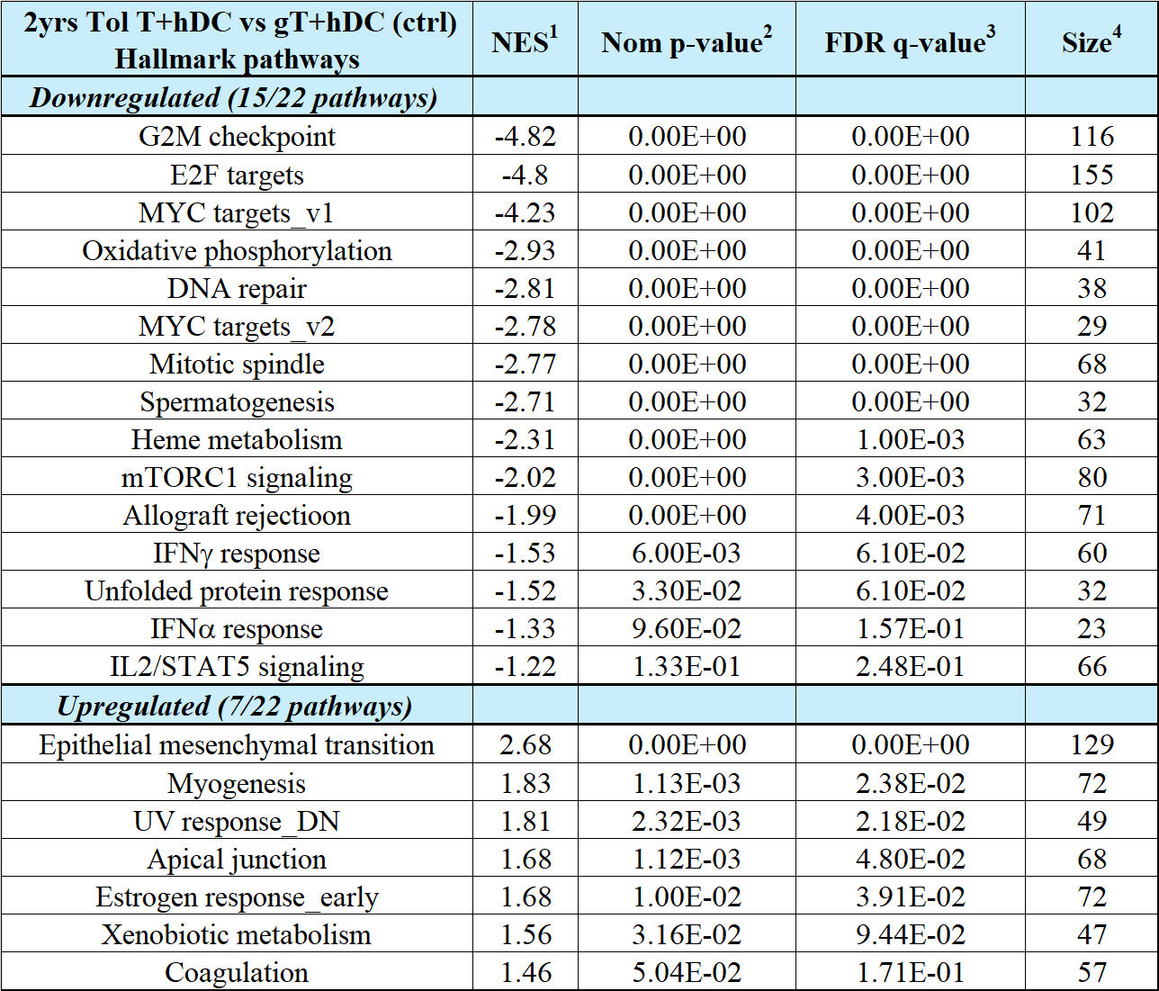

¹NES: Normalized enrichment score which reflects the degree to which a gene set (or pathway) is concentrated at top (upregulated) or bottom (downregulated) of the ranked list of genes in the expression dataset. Higher NES value (positive or negative) suggests that the gene set is more likely to be associated with observed phenotype (GSEA user guide).
²Nom p-value: Nominal p-value represents statistical significance of a gene set’s ES (GSEA user guide).
³FDR q-value is ‘False discovery rate’ that is the estimated probability that NES represents a false positive finding. GSEA recommends an FDR threshold of 0.25 or less. A lower q-value indicates a higher confidence in the significance of a gene set (GSEA user guide).
⁴Size: number of genes in the gene set after filtering out those genes not in the expression dataset (GSEA user guide).

Supplemental Table 7. Signaling pathway profiles analyzed by IPA software contrasting circulating donor-derived tolerant T cells (Tol T, 2 years post-BMT) and donor bone marrow graft T cells (gT) after in vitro stimulation.

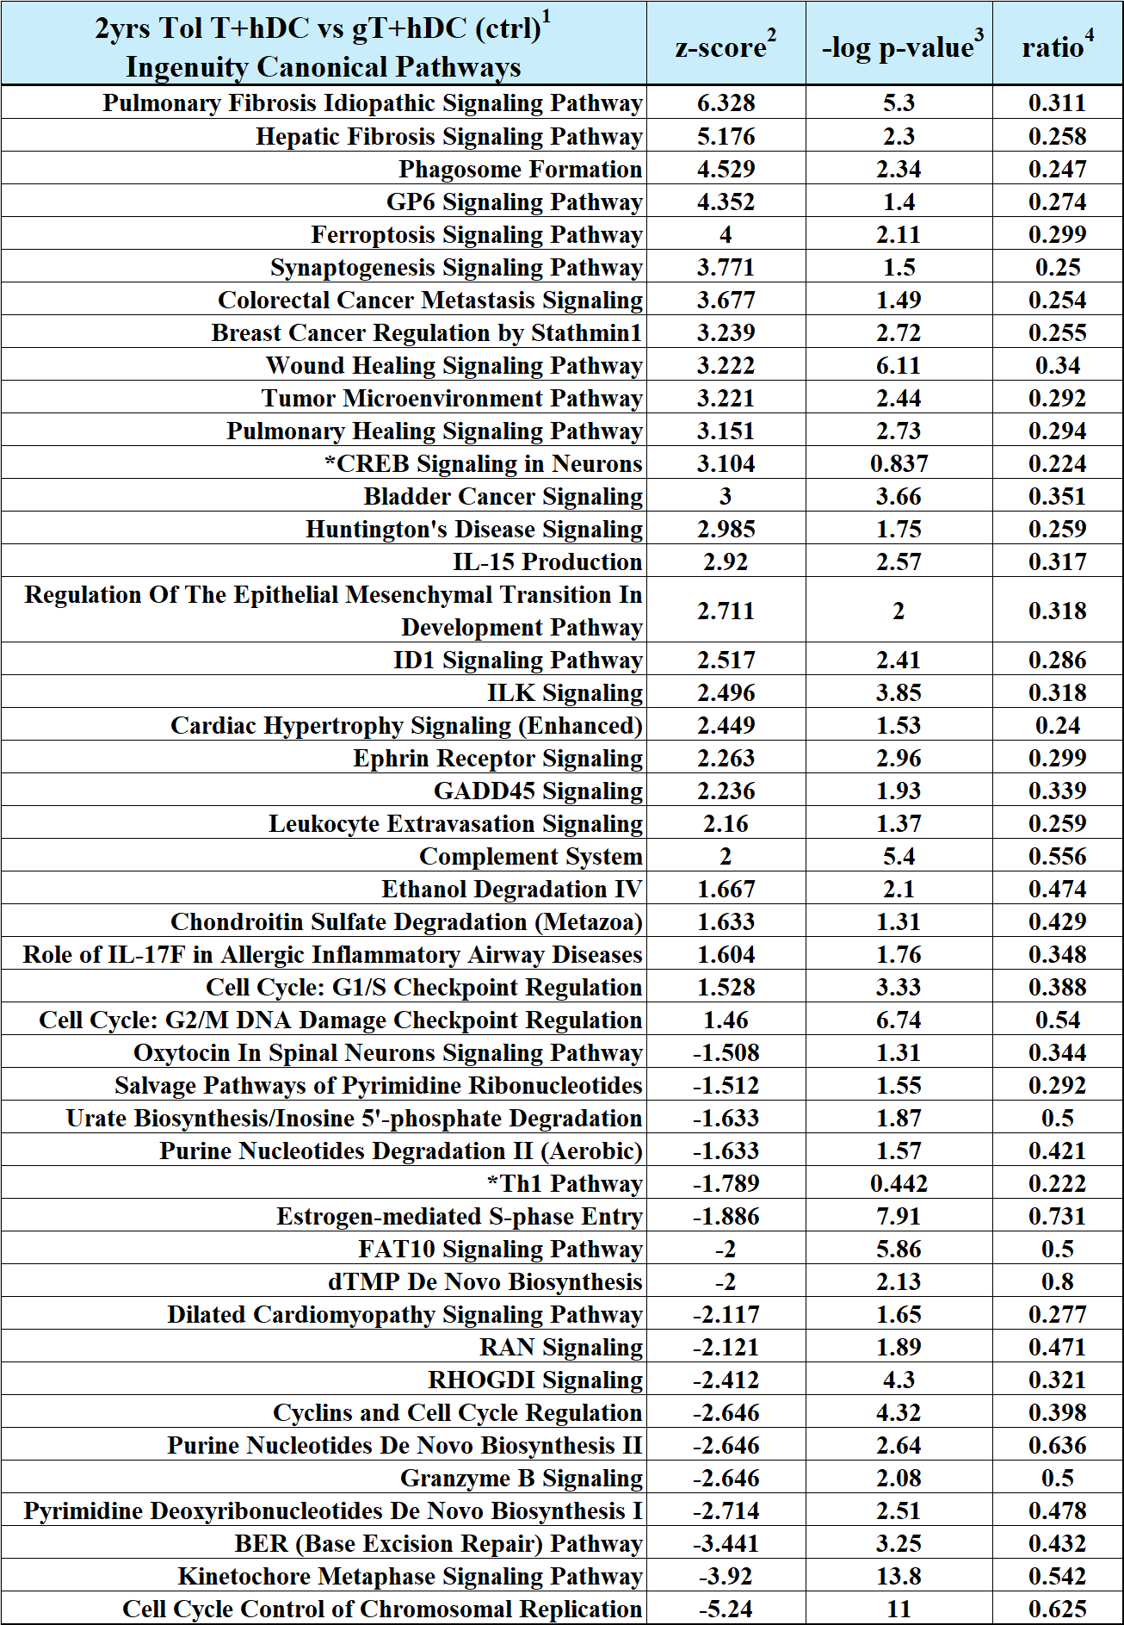

¹Comparison was made of the activation status for signaling pathways between circulating T cells (donor origin) in tolerant state (Tol T) 2-years post-BMT and graft T cells (gT). Both cell types were stimulated with hDC in vitro, with graft T cells + hDC serving as a control. The comparison utilized RNAseq gene differential expression data sets generated by CLC Genomics Workbench software and well-established signaling pathways database from IPA software.
²z-score: IPA software calculates an ‘activation z-score’ for each pathway, indicating whether the pathway is likely to be activated or inhibited based on the direction of expression changes in the genes involved, as compared with the IPA database. Pathways were selected if their z-score ≥2 or ≤-2.
³-log p-value: It’s a transformed version of p-value that interprets the significance of pathway. IPA uses a default threshold of -log p-value ≥1.3. The higher value holds greater significance.
⁴Ratio: proportion of presented dataset genes in the total number of genes in that pathway within the IPA reference set.
*These 2 pathways had z-score ≥2 or ≤-2 after hDC stimulation even though their -log p-value <1.3.

Supplemental Table 8. Signaling pathway profiles analyzed by IPA software contrasting tolerant T cells (Tol T, 2 years post-BMT) and bone marrow graft T cells (gT) without any in vitro stimulation.

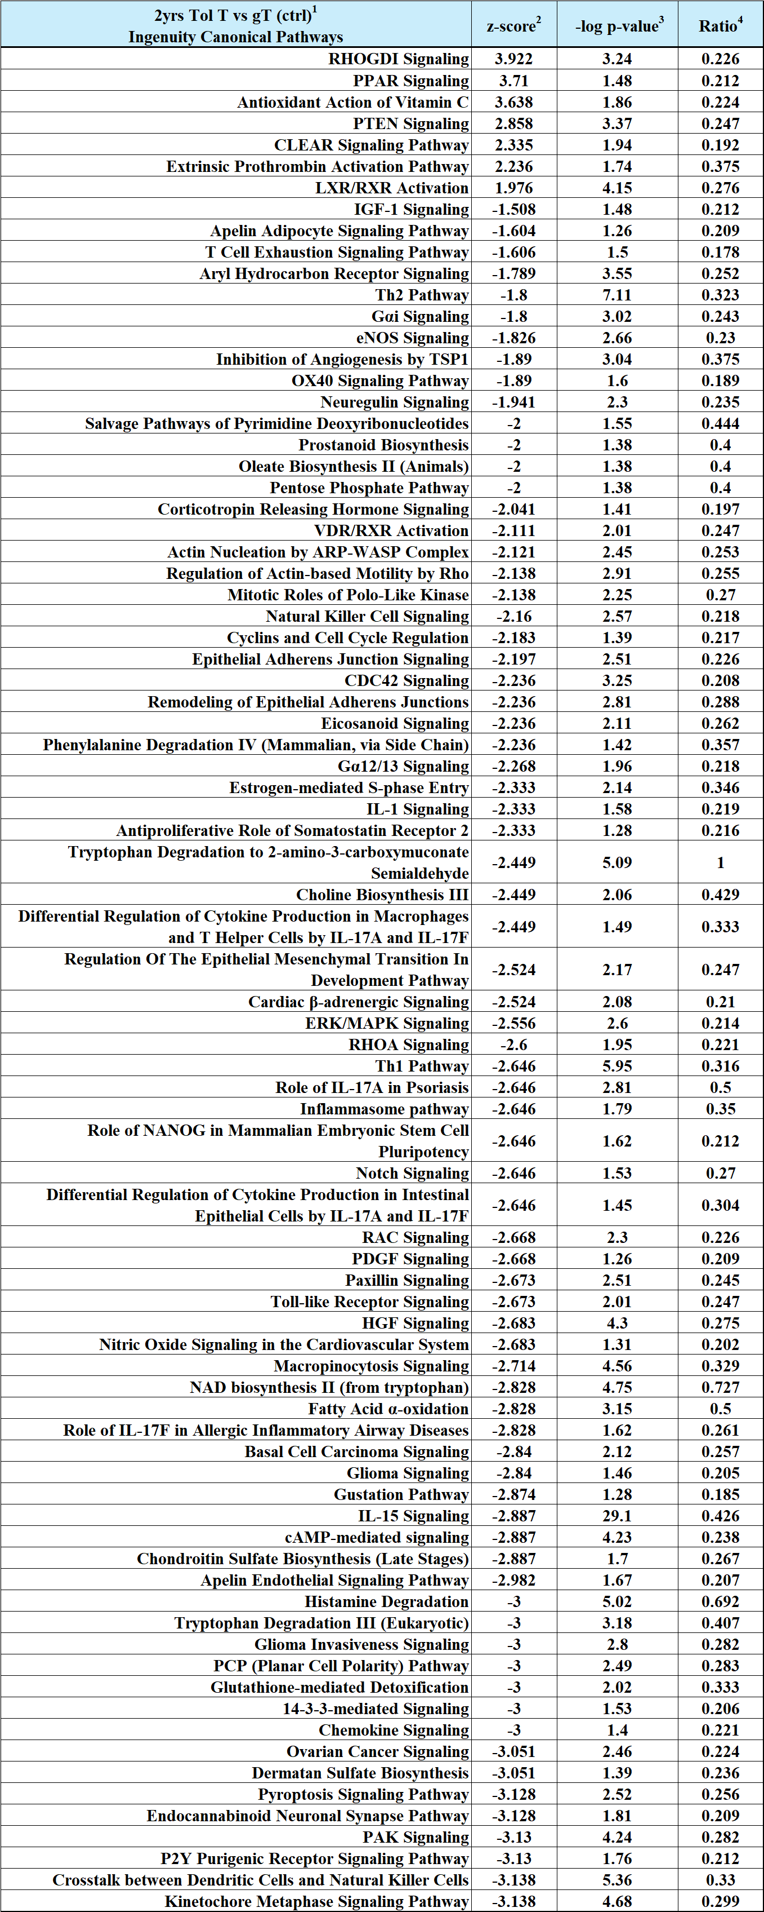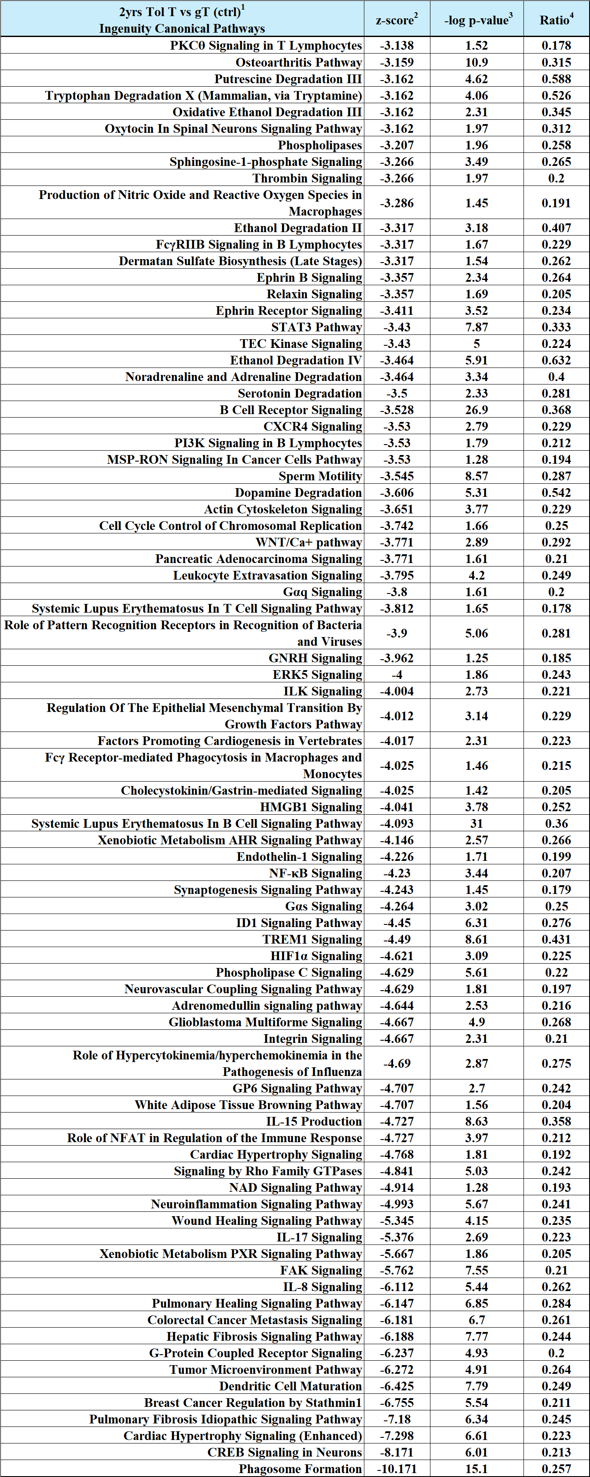
¹Comparison was made of the activation status for signaling pathways between circulating T cells (donor origin) in tolerant state (Tol T) 2-years post-BMT and graft T cells (gT), without hDC in vitro stimulation. Graft T cells served as a control. The comparison utilized RNAseq gene differential expression data sets generated by CLC Genomics Workbench software and well-established signaling pathways database from IPA software.
²z-score: IPA software calculates an ‘activation z-score’ for each pathway, indicating whether the pathway is likely to be activated or inhibited based on the direction of expression changes in the genes involved, as compared with the IPA. Pathways were selected if their z-score ≥2 or ≤-2.
³-log p-value: It’s a transformed version of p-value that interprets the significance of pathway. IPA uses a default threshold of -log p-value ≥1.3. The higher value holds greater significance.
⁴Ratio: proportion of presented dataset genes in the total number of genes in that pathway within the IPA reference set.

Supplemental Table 9. Signaling pathway profiles analyzed by IPA software contrasting co-existing circulating host and donor monocytes at 2 years post-BMT.

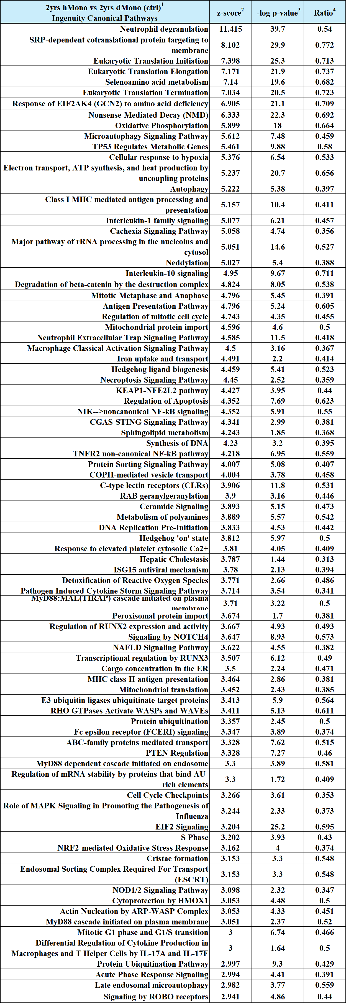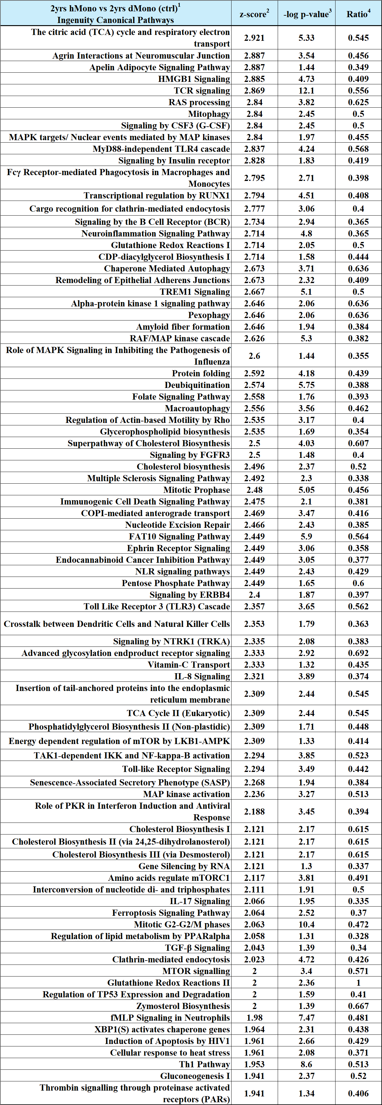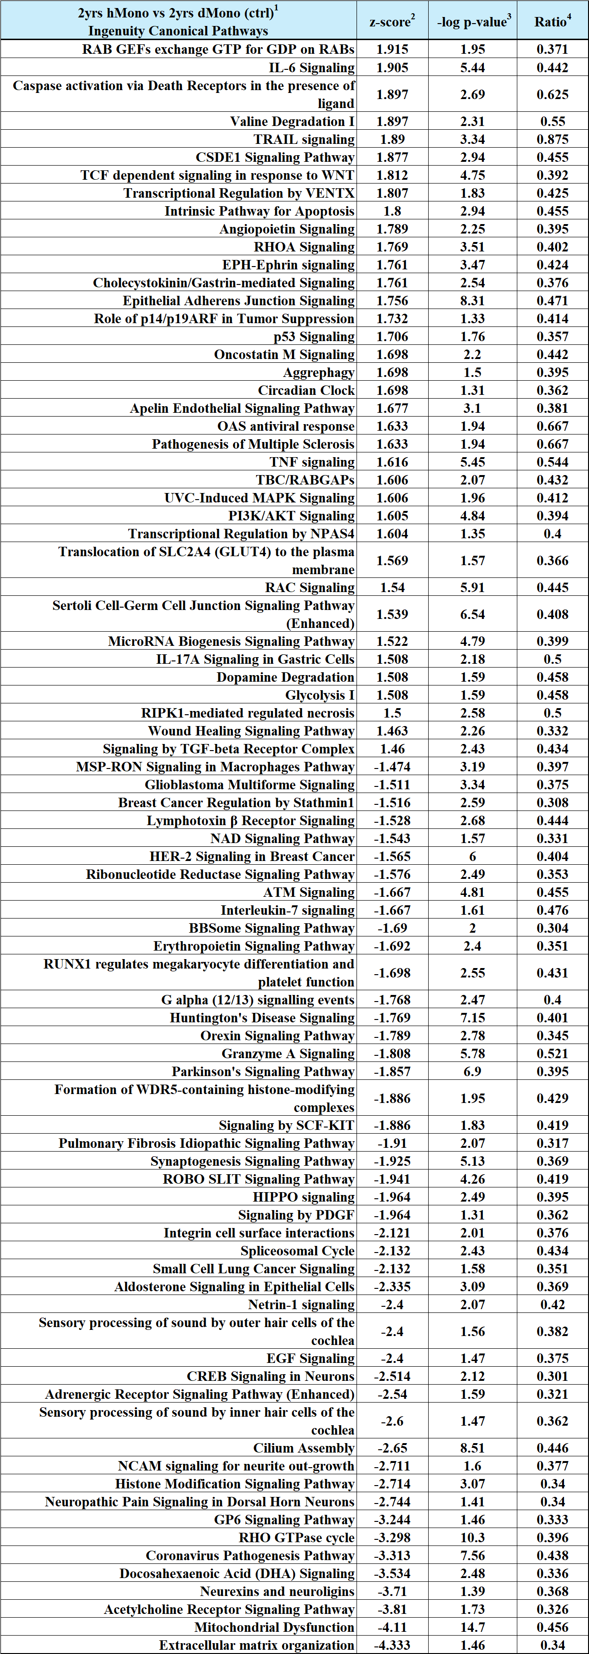

¹A comparison of the activation status of signaling pathways between host-monocytes (hMono) and donor monocytes (dMono) at tolerant stage 2-years post-BMT. The dMono was used as a control in comparison. The comparison was based on their RNAseq gene differential expression data sets generated by CLC Genomic Workbench software and the database of well-established signaling pathways from IPA software.
²z-score: IPA software calculates an ‘activation z-score’ for each pathway, indicating whether the pathway is likely to be activated or inhibited based on the direction of expression changes in the genes involved, as compared with the IPA database. Pathways were selected if their z-score ≥2 or ≤-2.
³-log p-value: It’s a transformed version of p-value that interprets the significance of pathway. IPA uses a default threshold of -log p-value ≥1.3. The higher value holds greater significance.
⁴Ratio: proportion of presented dataset genes in the total number of genes in that pathway within the IPA reference set.

