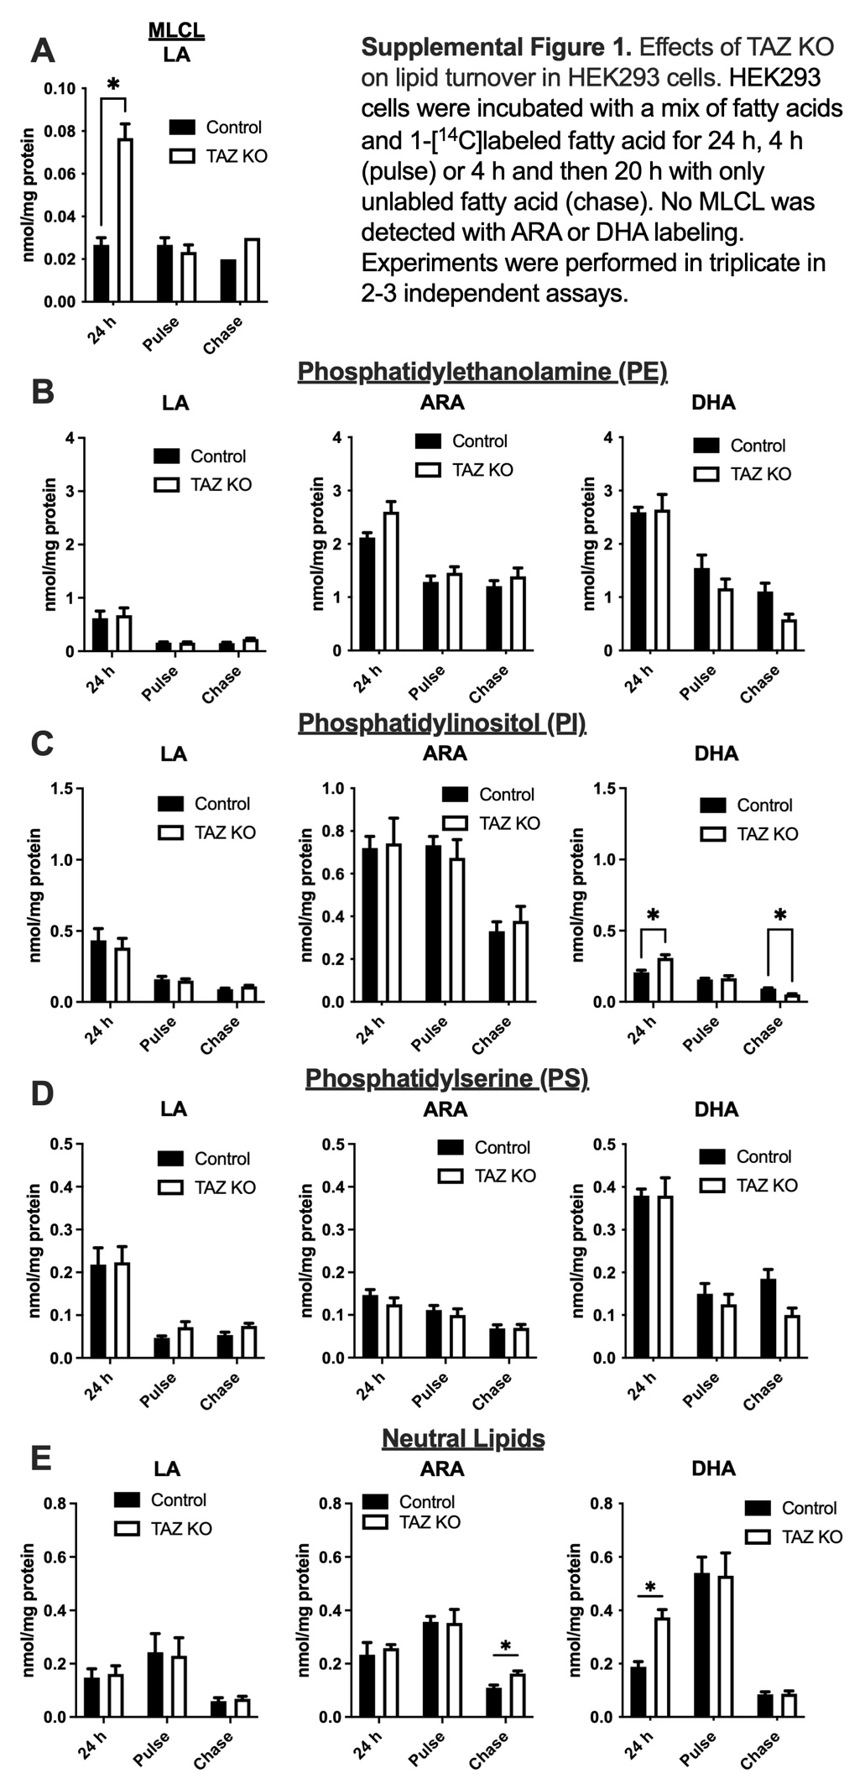
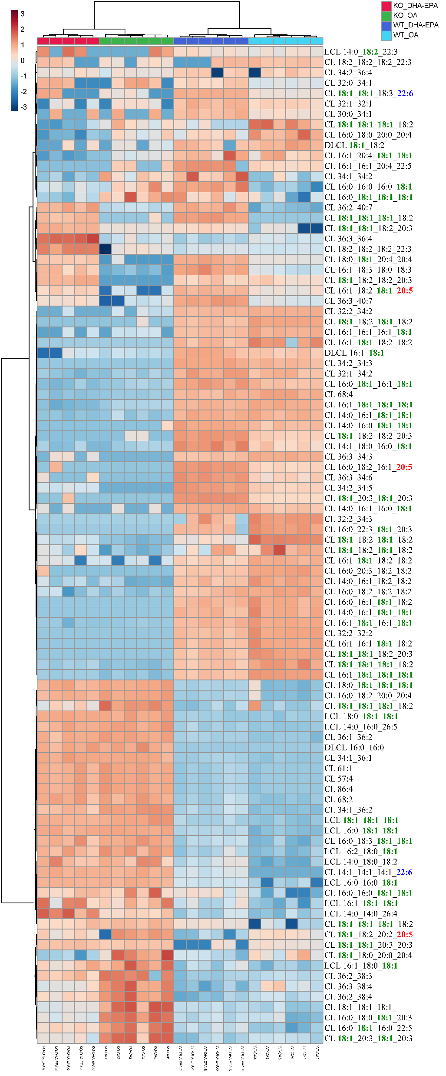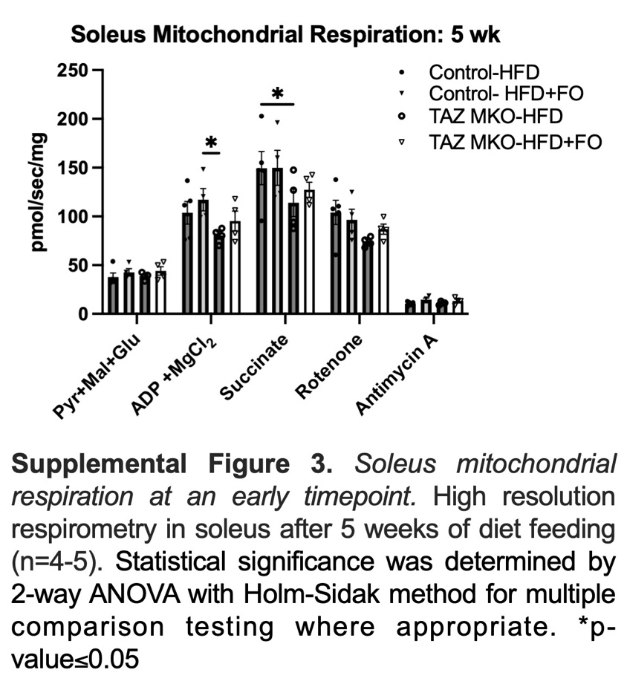
Supplemental Figure 2: Lipidomics analysis of WT and TAZ KO C2C12 cells. Forrest Plots of all lipid classes with (A-B) treatment or (C-D) genotype. (E) Heatmap of all Cardiolipin species. (n=5-6)

Supplemental Figure 4: Proteomics analysis of Control and TAZ MKO gastrocnemius. Volcano plots showing (A-B) genotype (TAZ MKO vs WT) or (C-D) diet (HFD vs HFD+FO) (n=4-6)
