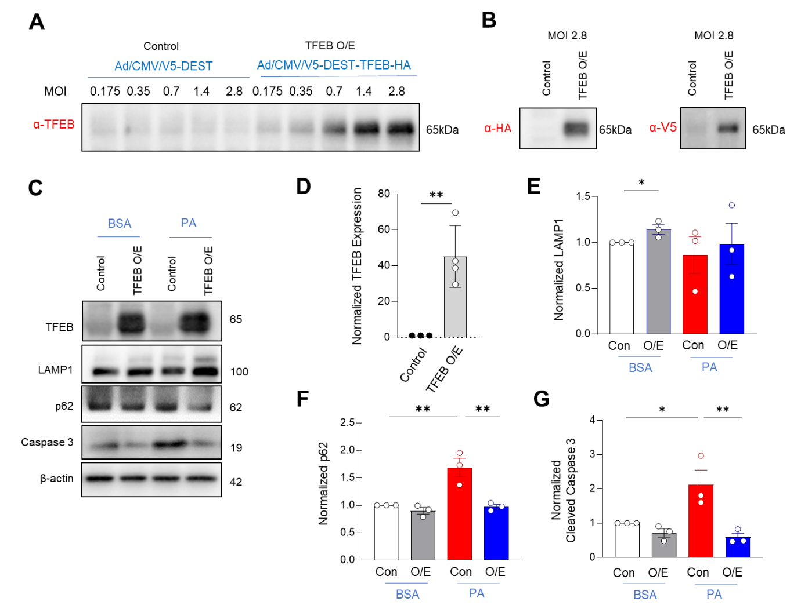

Supplementary Figure S1. Overexpression of TFEB alleviated palmitate-induced autophagy impairment and cytotoxicity. (A & B) MIN6 cells were infected with adenoviruses encoding either wild type TFEB (Ad/CMV/V5-DEST-TFEB-HA) or an empty vector control (Ad/CMV/V5-DEST). Expression of TFEB was confirmed by Western blot using anti-TFEB (A), anti-HA (B), and anti-V5 (B). (C-G) Overexpression of TFEB upregulated lysosomal protein LAMP1 (E), restored p62 clearance (F), and prevented Caspase-3 activation (G) in palmitate-treated MIN6 cells. Data are presented as means ± standard errors from three independent experiments. Statistical significance was determined using unpaired two-tailed Student’s t-test (D) or one-way ANOVA with post-hoc Tukey multiple comparison test (E-G). *p<0.05; **p<0.01.

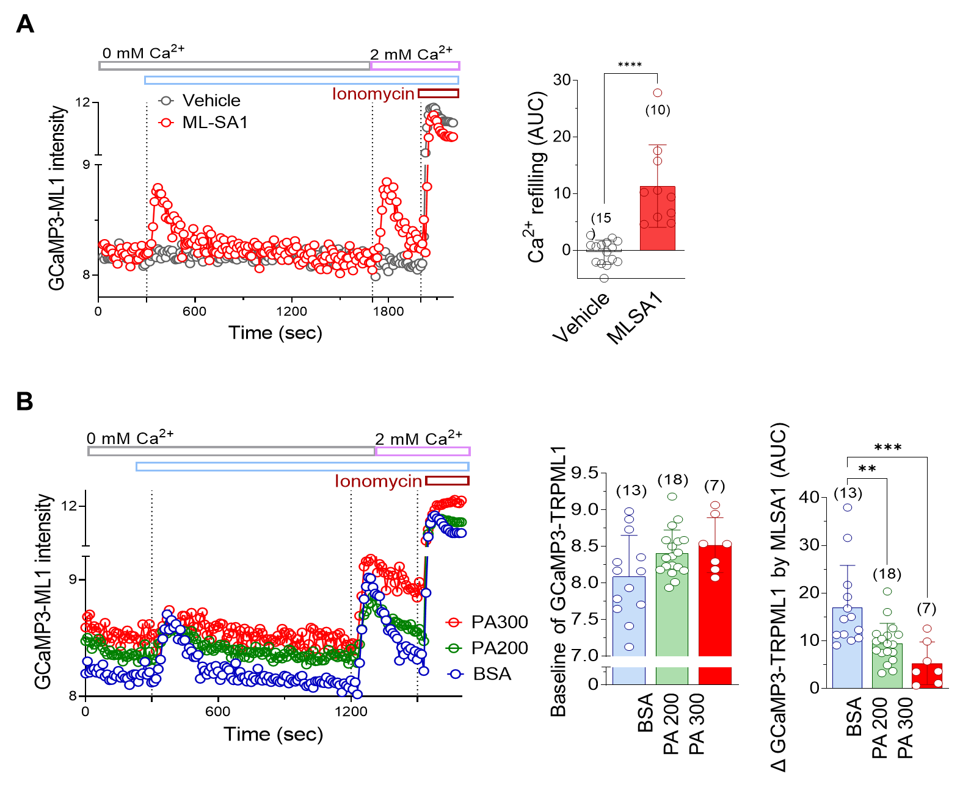

Supplementary Figure S2. Perilysosomal Ca²⁺ measurement using high-throughput fluorescence reader with GCaMP3-TRPML1-expressing cells. (A) Perilysosomal Ca²⁺ rise upon extracellular Ca²⁺ addition, mediated by MLSA1-triggered SOCE. (B) Elevated the baseline level of perilysosomal Ca²⁺, but abolished MLSA1 response by palmitate (PA) in multi-well plates seeded with GCaMP3-TRPML1-expressing HEK cells. Fluorescence intensity from each well were measured by using FlexStation. (n) is the number of analyzed wells from at least 3 independent experiments. Statistical significance was determined using unpaired two-tailed Student’s t-test (A) or one-way ANOVA with post-hoc Tukey multiple comparison test (B). **p<0.01; ***p<0.001; ****p<0.0001.

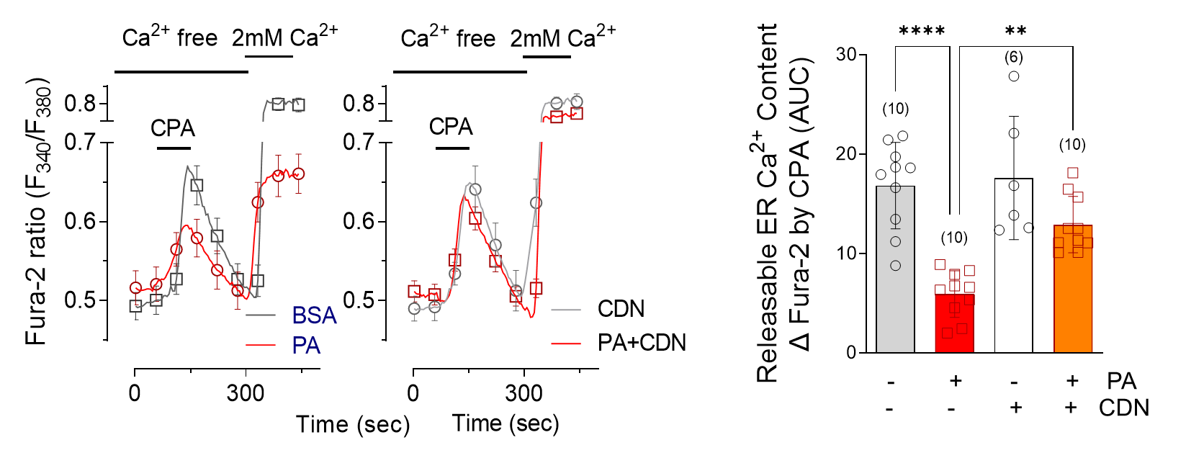

Supplementary Figure S3. SERCA activator recovers ER Ca²⁺ depletion by palmitate. ER Ca²⁺ release due to cyclopiazonic acid (CPA) was reduced in palmitate-treated MIN6 cells, which was normalized by pretreatment with CDN1163, a SERCA activator. Data are presented as means ± standard deviations and (n) is the number of analyzed cells from more than 3 independent experiments. Statistical significance was determined using one-way ANOVA with post-hoc Tukey multiple comparison test. **p<0.01; ****p<0.0001.

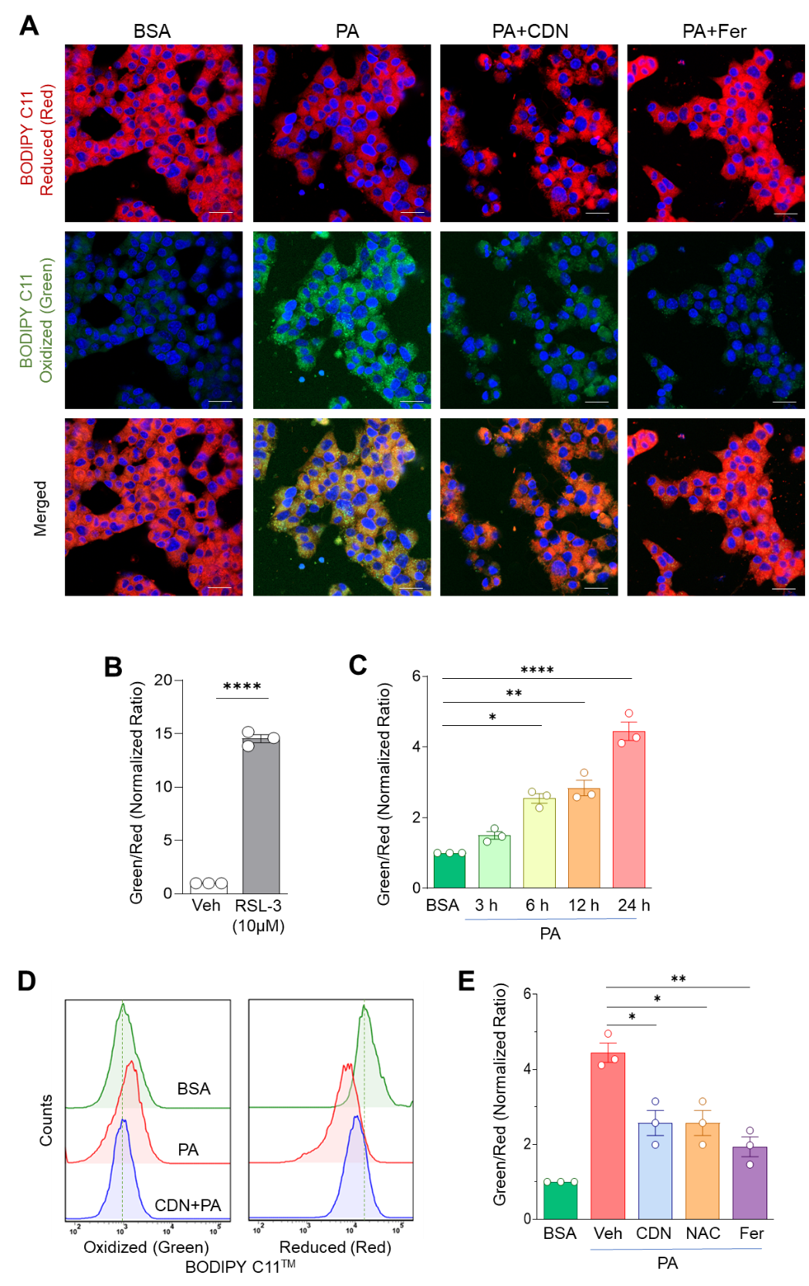

Supplementary Figure S4. SERCA activator and antioxidant mitigate palmitate-induced ferroptotic lipid peroxidation. (A) Lipid peroxidation associated with ferroptosis in MIN6 cells was estimated by confocal imaging using BODIPY C11; increased green and decreased red fluorescence indicating ferroptosis. (B-E) BODIPY C11 fluorescence shifts were analyzed by flow cytometry. RSL-3, a ferroptosis inducer through glutathione peroxidase inhibition, increased the green-to-red fluorescence ratio (B). Palmitate also elevated this ratio in a time-dependent manner, suggesting ferroptotic lipid peroxidation. CDN1163, a small-molecule SERCA activator (D & E), and the antioxidant N-acetyl cysteine (NAC; E) reduced palmitate-induced ferroptosis. Additionally, ferrostatin (Fer), a ferroptosis inhibitor, abolished palmitate-induced peroxidation, confirming that the lipid peroxidation was ferroptotic. Data are expressed as means ± standard errors from three independent experiments. Statistical significance was determined using unpaired two-tailed Student’s t-test (B) or one-way ANOVA with post-hoc Tukey multiple comparison test (C, E). *p<0.05; **p<0.01; ****p<0.0001.

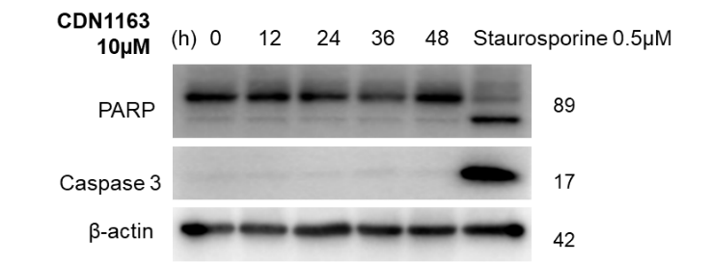

Supplementary Figure S5. CDN1163, a SERCA activator, does not induce cytotoxicity. Cytotoxicity was assessed by detecting PARP cleavage and activated Caspase-3 via Western blot analysis. Incubating MIN6 cells with CDN1163 (10 μM) for 48 h showed no signs of cytotoxicity, whereas treatment with staurosporine (0.5 μM, 8 h) resulted in PARP cleavage and activated Caspase-3.

Supplementary Table 1. Reagents and Tools

Reagents/Resources | Reference/Source | Identifier/Catalogue Number
Antibodies
Rabbit anti-SERCA2 | Cell Signaling T. | Cat. 9580, RRID:AB_10827913
Rabbit anti-p62 | Cell Signaling T. | Cat.8025, RRID: AB_10562134
Rabbit anti-LC3 | Cell Signaling T. | Cat.12741, RRID: AB_2278129
Rabbit anti-p-p70S6K | Cell Signaling T. | Cat.9234, RRID: AB_330944
Rabbit anti-t-p70S6K | Cell Signaling T. | Cat.9202, RRID: AB_330930
Rabbit anti-p-ACC | Cell Signaling T. | Cat.3661, RRID: AB_330337
Rabbit anti-t-ACC | Cell Signaling T. | Cat.3662, RRID: AB_2223182
Rabbit anti-p-AMPK | Cell Signaling T. | Cat.2535, RRID: AB_330330
Rabbit anti-t-AMPK | Cell Signaling T. | Cat.2532, RRID: AB_10622186
Rabbit anti Cleaved Caspase 3 | Cell Signaling T. | Cat.9661, RRID: AB_2341188
Rabbit anti-TFEB | Cell Signaling T. | Cat.37785, RRID: AB_2799103
Rabbit anti-LaminA/C | Cell Signaling T. | Cat.2032, RRID: AB_2136278
Mouse anti-β actin | Proteintech | Cat. 20536-1-AP, RRID: AB_10700003
Mouse anti-alpha tubulin | DSHB | Cat# 12G10, RRID: AB_1157911
Rabbit anti-LAMP2 | Cell Signaling T. | Cat. 49067, RRID: AB_2798843
Mouse anti-LAMP1 | Santa Cruz Bio. | Cat. 20011, RRID: AB_626853
Rabbit anti-TFEB | Proteintech | Cat. 13372-1, RRID: AB_2199611
Mouse anti-V5-Tag | Invitrogen | Cat. R960-25, RRID: AB_2556564
Rabbit anti-HA-Tag | Cell Signaling T. | Cat. 3724, RRID:AB_1549585
Rabbit anti-PARP | Cell Signaling T. | Cat. 9542, RRID:AB_2160739
Chemicals, Reagents
CDN1163 | Sigma Aldrich |  | Cat. SML1682
Torin-1 | Sigma Aldrich |  | Cat. 475991
CM-H2DCFDA | Invitrogen |  | Cat. C6827
mitoSOX | Invitrogen |  | Cat. M36008
GPN | Santa Cruz Biotechnology |  | Cat. G6149
MLSA1 | Sigma Aldrich |  | Cat. SML0627
Ionomycin | Alomone labs |  | Cat. I-700
Menadione | Sigma Aldrich |  | Cat. M5625
H₂O₂ | Sigma Aldrich |  | Cat. H1009
MitoTEMPO | Sigma Aldrich |  | Cat. SML0737
BAPTA-AM | Sigma Aldrich |  | Cat. A1076
W7 | Sigma Aldrich |  | Cat. A4844
KN62 | Sigma Aldrich |  | Cat. K1125
Verapamil | Sigma Aldrich |  | Cat. V4629
Nimodipine | Sigma Aldrich |  | Cat. N149
Diazoxide | Sigma Aldrich |  | Cat. D9035
Fura-2 AM | Invitrogen |  | Cat. IN-F1201
JC-1 | Invitrogen |  | Cat. T3168
Cyclopiazonic acid (CPA) | Sigma Aldrich |  | Cat. C1530
Oligomycin | Sigma Aldrich |  | Cat. 75351
FCCP | Sigma Aldrich |  | Cat. C2920
Rotenone | Sigma Aldrich |  | Cat. R8875
Anitmycin A | Sigma Aldrich |  | Cat. A8674
Paraformaldehyde | Sigma Aldrich |  | Cat. P6148
Sodium Palmitate | Sigma Aldrich |  | Cat. P9767
Bovine serum albumin | Sigma Aldrich |  | Cat. A6003
DAPI Fluoromount-G | Roche |  | Cat. 10236276001
Ribo EX | GeneAll |  | Cat. 301-001
Beta-mercaptoethanol | Sigma Aldrich |  | Cat. M6250
RIPA buffer | SupremeTech |  | Cat. ST1090-RI
Phosphatase inhibitor  (PhosSTOP) | Roche |  | Cat. 4906845001
Protease inhibitor | Roche |  | Cat. 5892791001
X-tremeGENE HP DNA Transfection Reagent | Roche |  | Cat. 6366236001
OptiMEM I | Thermo Fisher Scientific |  | Cat. 31985-062
BODIPYTM 581/591 C11 | Thermo Fisher Scientific |  | Cat.D3861
Critical commercial assays
MTT | Sigma Aldrich |  | Cat. M2128
Cell Death Detection ELISA kit | Roche |  | Cat. 11774425001
Adeno-XTM Rapid Titer kit | Takara |  | Cat. 632250
Experimental models
MIN6 | AddexBio |  | RRID:CVCL_0431
C57BL/6N | DBL
Software and algorithms
Prism 9.1 | GraphPad |  | GP9-1988787-RLRM-FA1F1
Image J
Others
siATP2a2 | Dharmacon |  | Cat. M040968-02-0050
Human SERCA2a (pcDNA3.1+) | Addgene |  | Cat. 75187
Human SERCA2b (pcDNA3.1+) | Addgene |  | Cat. 75188
pCAG G-CEPIA1er | Addgene |  | Cat. 105012
2mt-CEPIA plasmid | Addgene |  | Cat. 58218
GCaMP3-TRPML1 | from Prof. Xu
LC3-GFP-RFP | Addgene |  | Cat. 21074
TFEB-pEGFP | Addgene |  | Cat. 38119
pcDNA3-Lyso-TORCAR | Addgene |  | Cat. 64929

