Title: A tailored in vivo CRISPR screen identifies BAP1 as potent tumor suppressors of sarcoma

Authorship: Jianguo Huang ^{1*}, Xingliang Liu ¹, Warren Floyd ^{2#}, William Haugh ¹, Zhaoyu Sun ¹, Melissa J. Kasiewicz ¹, Yaping Wu ¹, Brian Piening ¹, John T. Welle ¹, Wesley K. Rosales ¹, Venkatesh Rajamanickam ¹, So Young Kim ³, Eric Xu ², Lixia Luo ², Yan Ma ², Rutulkumar Patel ^{2$}, Ziqiang Zhang ⁴, Brady Bernard ¹, William L. Redmond ¹, Walter J. Urba ¹, R Bryan Bell, David G. Kirsch ^{2,5,6,7,8*}

* Equal contribution, co-corresponding authors

¹ Earle A. Chiles Research Institute, Providence Cancer Institute, Portland, OR 97213

² Department of Radiation Oncology, Duke University Medical Center, Durham, NC 27710

³ Department of Molecular Genetics and Microbiology, Duke University, Durham, NC 27710

⁴ Department of Respiratory and Critical Care Medicine, Shanghai Pudong Hospital, Fudan University Pudong Medical Center, Pudong Hospital of Fudan University, Shanghai, China

⁵ Department of Pharmacology and Cancer Biology, Duke University Medical Center, Durham,
NC 27710

⁶ Radiation Medicine Program, Princess Margaret Cancer Center, University Health Network, Toronto, ON, Canada

⁷ Department of Radiation Oncology, University of Toronto, Toronto, ON, Canada

⁸ Department of Medical Biophysics, University of Toronto, Toronto, ON, Canada

# Current position: Division of Radiation Oncology, University of Texas MD Anderson Cancer Center, Houston, TX 77030

$ Department of Radiation Oncology, Baylor College of Medicine, Houston, TX 77030

* Corresponding authors: Jianguo Huang, Earle A. Chiles Research Institute, Providence Cancer Institute, Portland, OR 97213 (Email: Jianguo.huang@providence.org), and David G. Kirsch, Department of Radiation Oncology, Radiation Medicine Program, University of Toronto, Princess Margaret Cancer Center, Toronto, ON, Canada (Email: david.kirsch@uhn.ca)

Supplementary Figure 1. Copy numbers of each sgRNA in the three libraries by sequencing.

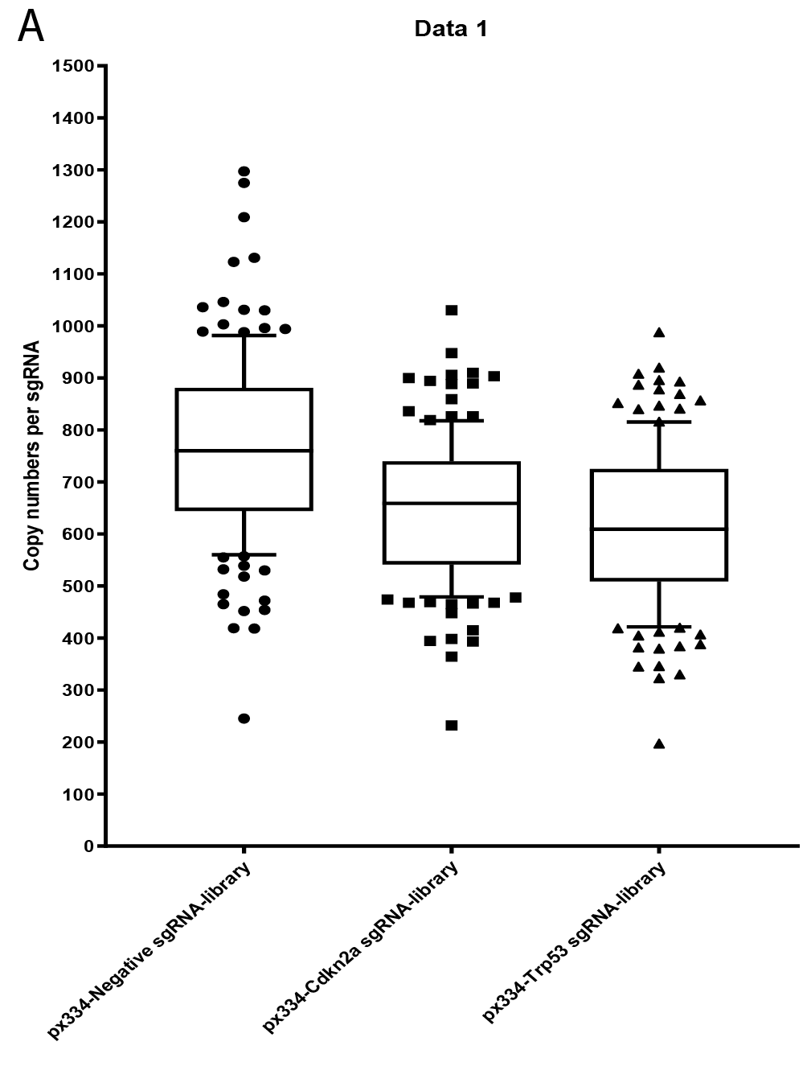

Supplementary Figure 2. Tumor free survival in Rosa26 ^{LoxP-Cas9/+} mice following IVE delivery of three different libraries. 5 mice per group.

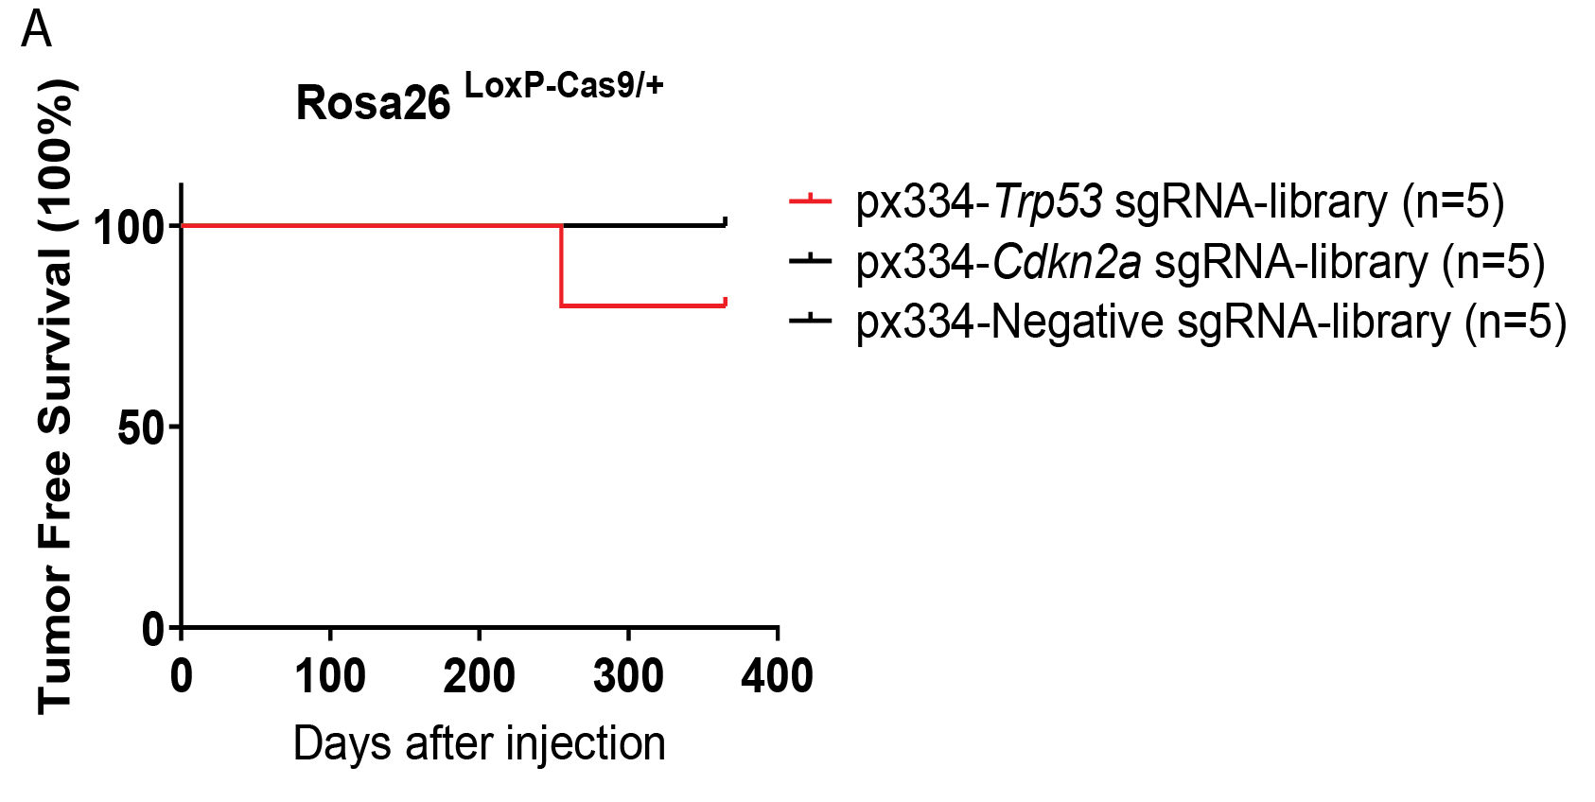

Supplementary Figure 3. (A) The Rosa26 ^{LoxP-Cas9/LoxP-Cas9} mice were intramuscularly injected (IVE) with 50 µg of mixed plasmids containing px333-Trp53-Pten sgRNAs and the px334-Trp53 sgRNA-library at a 1-1 ratio.

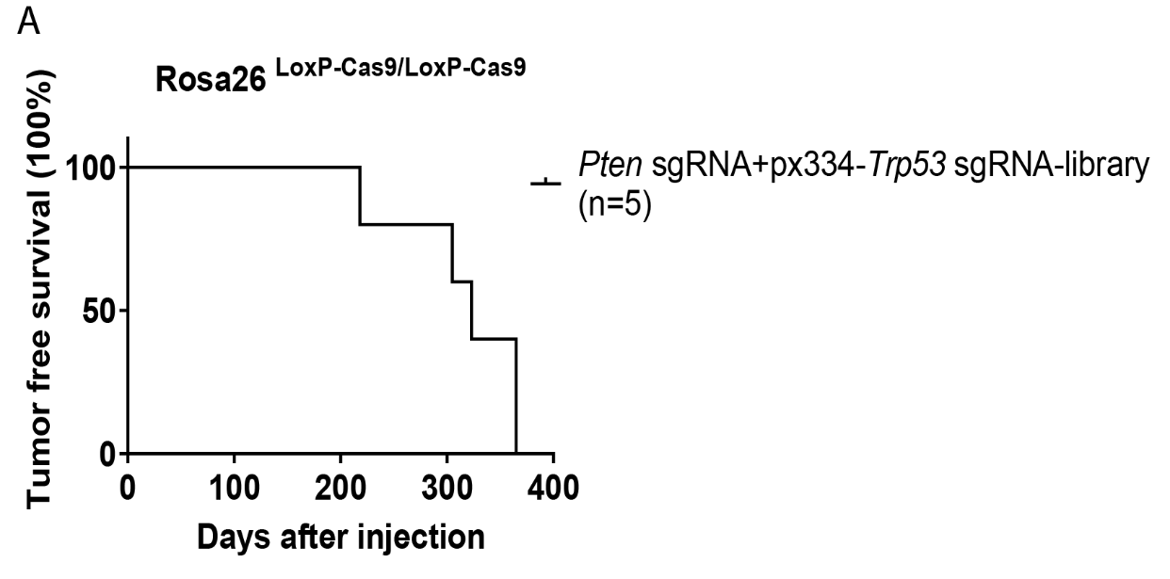

Supplementary Figure 4. (A) T7EI assay was performed to detect Indels in tumor DNAs induced by the px334-Trp53 sgRNA-library. (B) Sanger sequencing with Inference of CRISPR Edits (ICE) analysis was used to calculate the percentage of Indels in tumor S1 induced by the pX334-Trp53 sgRNA-library. (C) Next generation sequencing analysis was used to calculate the percentage of Indels in tumor S7, S11, and S13 induced by the pX334-Trp53 sgRNA-library.
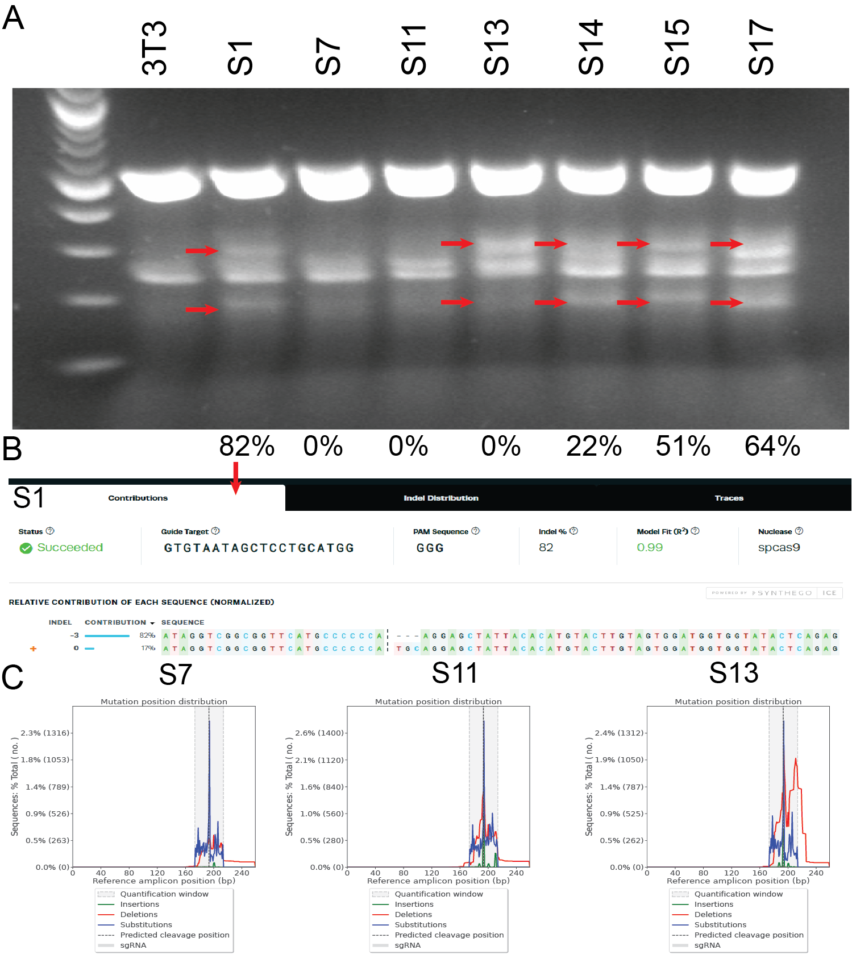

Supplementary Figure 5. No tumors were detected in mice IVE of plasmids containing either Trp53-Mllt3 sgRNAs, Trp53-Crebbp sgRNAs, Trp53-Pbrm1 sgRNAs, Trp53-Cysltr2, Trp53-Mst1r, or Trp53-Fat1 sgRNAs.

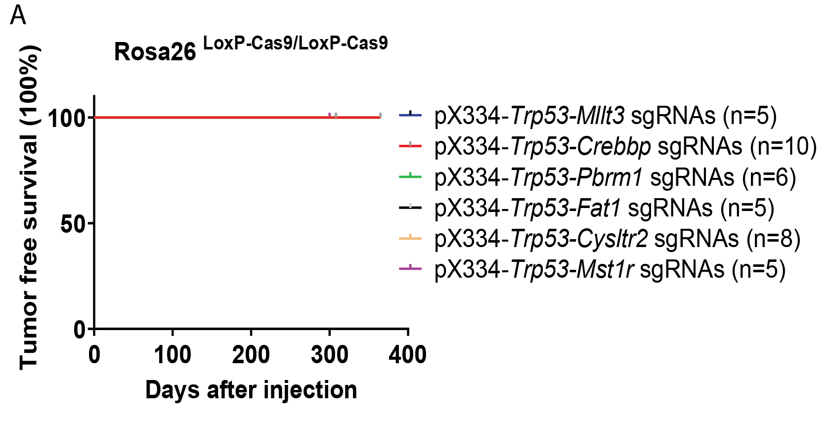

Supplementary Figure 6. H&E staining of mouse tumors driven by various gene mutations shows that these tumors are similar to each other. Scale bar = 50 µm.

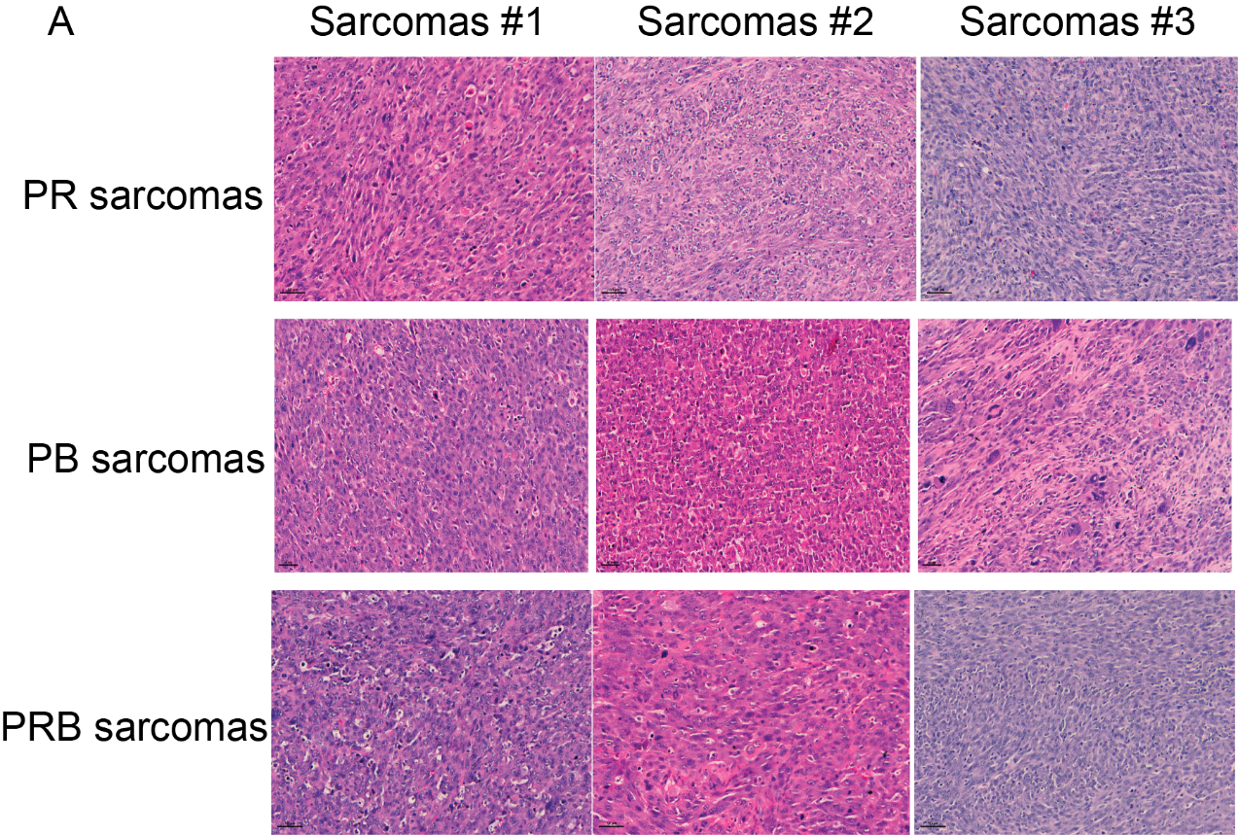

Supplementary Figure 7. Immunohistochemistry with CD68 in various mouse sarcoma tissue sections showed abundant CD68⁺ macrophages in the tumor. Scale bar = 100 µm.

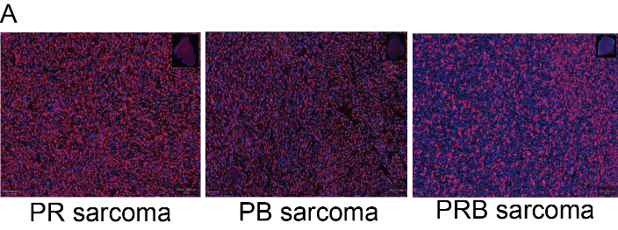

Supplementary Figure 8. (A) FC showed that there are no differences in the percentage of PD-1⁺CD8⁺ T cells between PR CRISPR large, PB CRISPR large and small tumors.

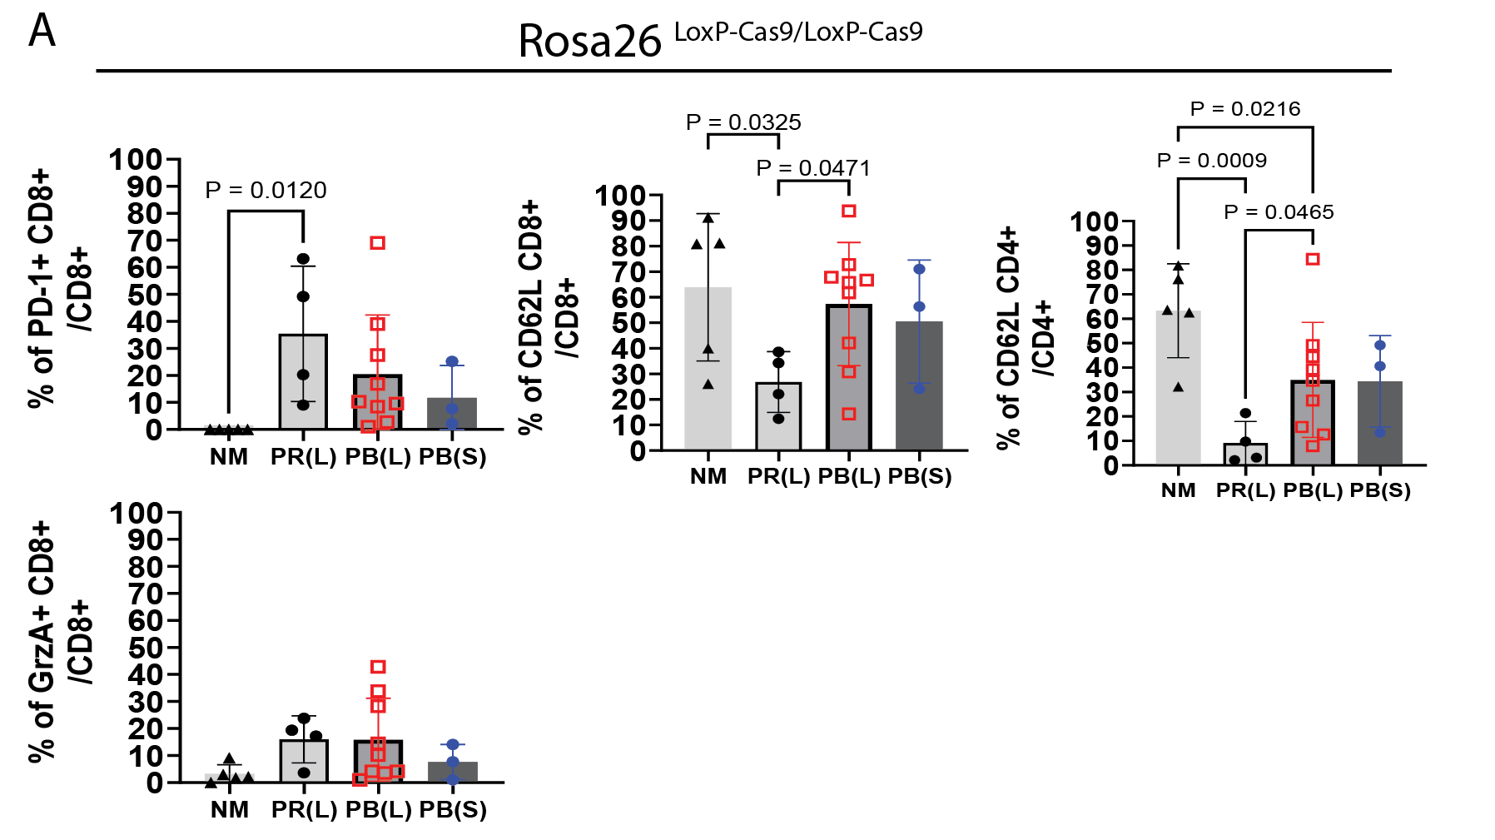

Supplementary Figure 9. (A) There are no differences in the percentage of CD11b⁺ cells between PR CRISPR large, and PB CRISPR large tumors. However, the percentage of CD11b⁺ cells is significantly lower in PB CRISPR early tumors compared to PB CRISPR large tumors. (B) Flow cytometry gating strategy to identify PMN-MDSCs, M-MDSCs, and TAMs. (C) There are no differences in the percentage of PMN-MDSCs, M-MDSCs, or TAMs between PB CRISPR large and small tumors. (D) There is a significantly low percentage of PD-L1⁺ M-MDSCs in PRB Cre/CRISPR tumors compared to PR Cre tumors.

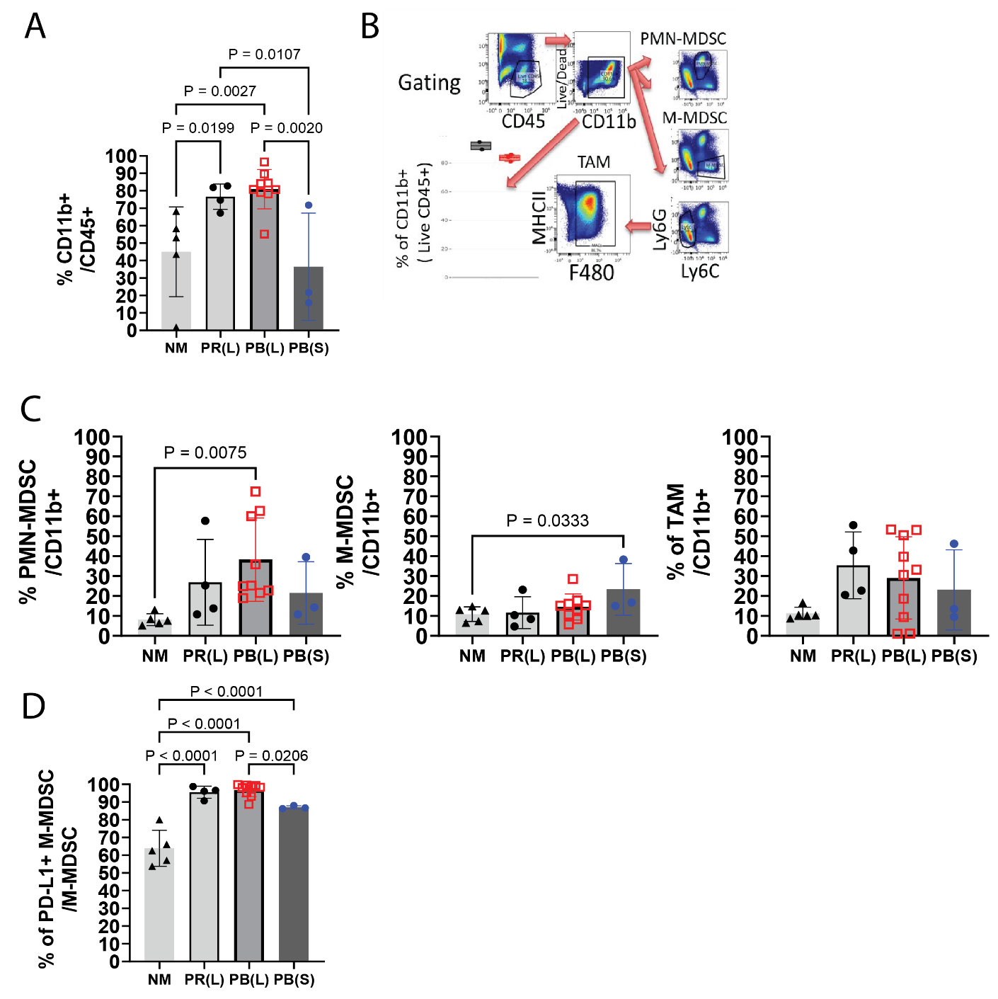

Supplementary Figure 10. (A) Western blot analysis to determine the knockout of Trp53 and Rb1 in PR cell lines. (B) Western blot analysis to determine the knockout of Trp53 and Bap1 in PB cell lines.

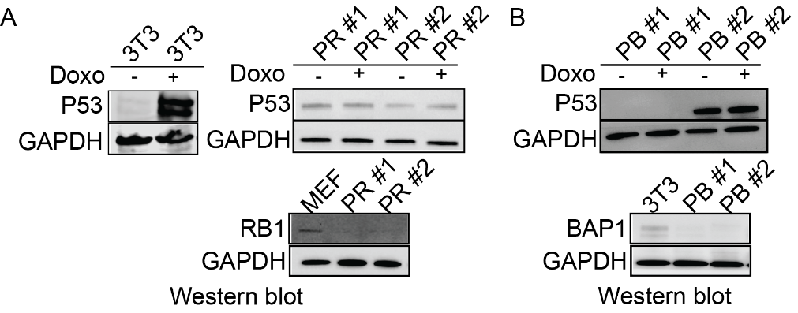
Supplementary Figure 11. (A) Both PR and PB mouse sarcoma cells are sensitive to two PARP inhibitors, niraparib and talazoparib, in a dose-dependent manner in vitro. (B) Niraparib significantly slows PR sarcoma growth in subcutaneous nude mice, while niraparib has no impact on PB sarcoma growth in subcutaneous nude mice. 5 mice in each group.

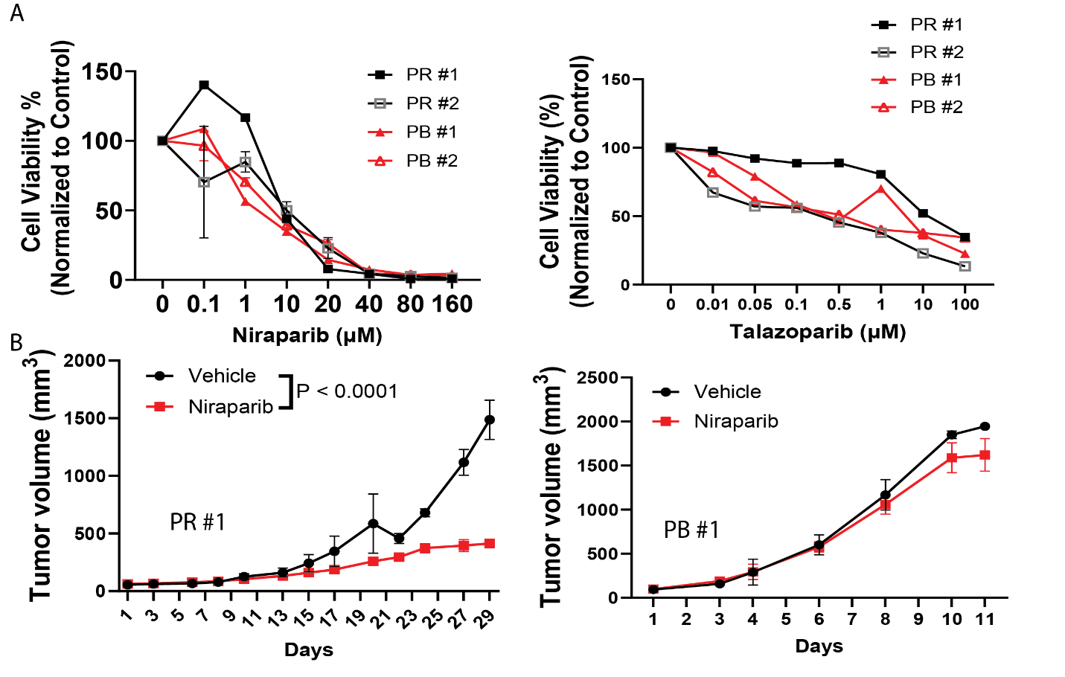

Supplementary Figure 12. There are no differences in the percentage of CD11b⁺ cells between vehicle and volasertib treatment group.
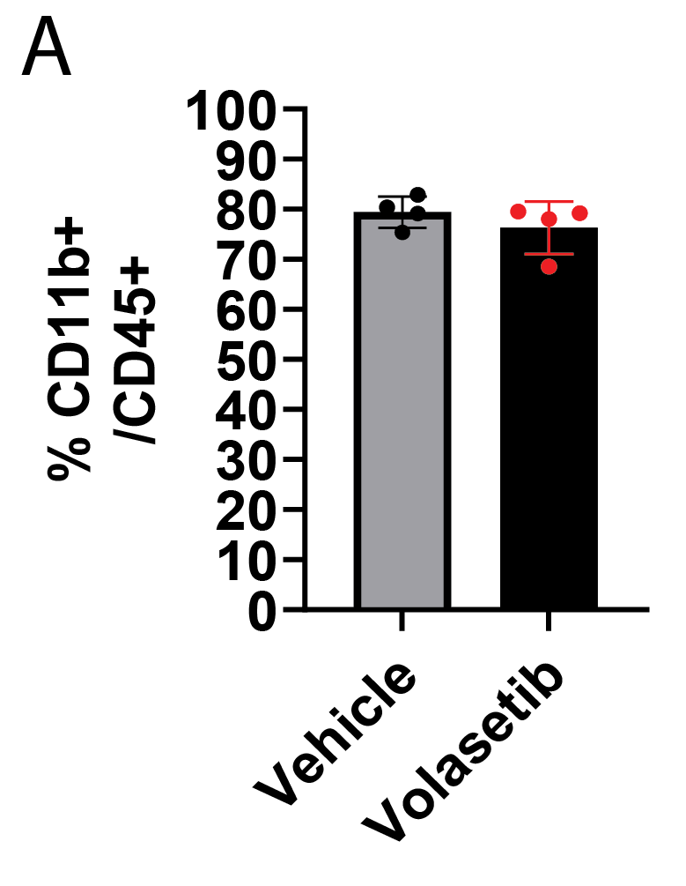

Supplementary Figure 13. Mutation profiling of PR-DUB complex genes in human UPS according to the TCGA database.

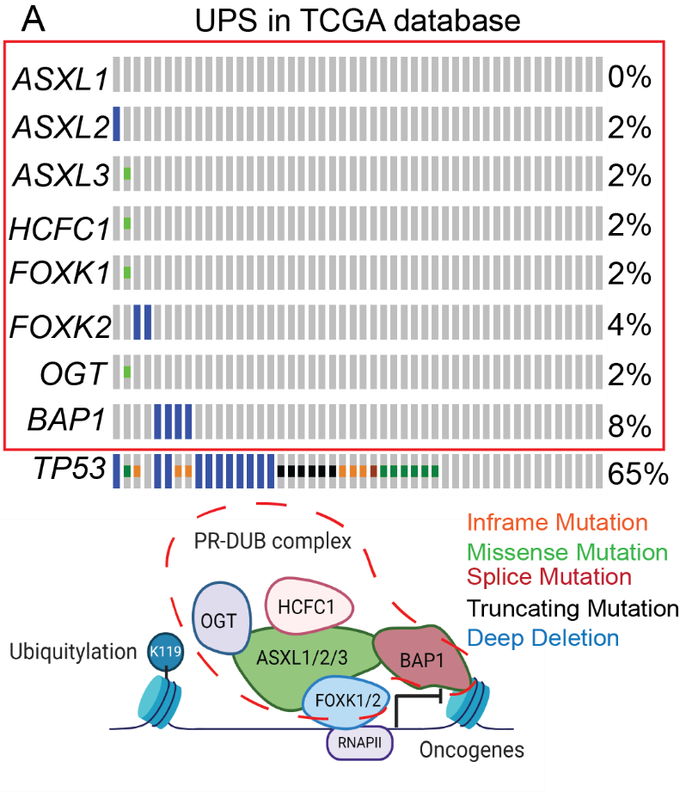

Supplementary Figure 14. Raw images of all western blotting are presented in this manuscript.

Supplementary Table 1. Top 35 genes plus TP53 and CDKN2A that are loss-of-function mutated or have copy number alterations in human UPSs and MFSs.

Supplementary Table 2. Next generation sequencing detected InDels in the Trp53 locus targeted by CRISPR/Cas9.

Supplementary Table 3. The rate of metastasis detected in the mice bearing different gene mutation driven tumors.

Supplementary Table 4. Oligonucleotides.

Supplementary Table 5. Oligonucleotide pools for synthesis.

Supplementary Table 6. Combined T-cell/MDSC panel.

