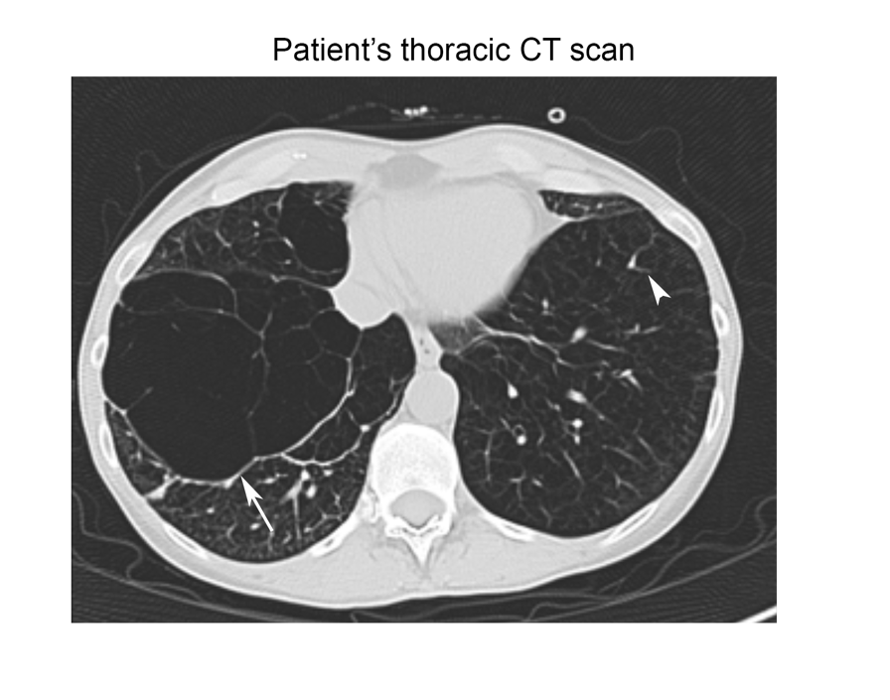

Supplementary Fig. 1. Representative image of the patient’s thoracic CT showing lower lobes of the lung involved with extensive emphysema, with loss of normal lung tissue density (arrowhead) and large bulla formation (arrow).

Supplementary Table S1. SNPs within IGSF3 associated with COPD phenotypes.

Supplementary Table ST2. Gene enrichment linked to subcellular localization in subject differentially expressed in patient versus control lymphoblastoids
GO cellular component complete | N (patient) | N (control) | Expected | Fold Enrichment | +/- | raw P value | FDR
endoplasmic reticulum chaperone complex | 11 | 5 | 0.39 | 12.86 | + | 1.46E-04 | 6.75E-03
ubiquitin conjugating enzyme complex | 9 | 4 | 0.32 | 12.58 | + | 7.52E-04 | 2.79E-02
endoplasmic reticulum exit site | 27 | 7 | 0.95 | 7.34 | + | 1.26E-04 | 6.42E-03
rough endoplasmic reticulum membrane | 29 | 6 | 1.02 | 5.85 | + | 1.08E-03 | 3.66E-02
U2-type precatalytic spliceosome | 43 | 7 | 1.52 | 4.61 | + | 1.46E-03 | 4.65E-02
melanosome | 106 | 15 | 3.75 | 4 | + | 1.62E-05 | 9.73E-04
proteasome complex | 67 | 9 | 2.37 | 3.8 | + | 1.11E-03 | 3.70E-02
large ribosomal subunit | 125 | 13 | 4.42 | 2.94 | + | 9.04E-04 | 3.12E-02
mitochondrial protein complex | 272 | 22 | 9.61 | 2.29 | + | 5.52E-04 | 2.12E-02
focal adhesion | 404 | 31 | 14.28 | 2.17 | + | 1.34E-04 | 6.51E-03
extracellular exosome | 2097 | 133 | 74.11 | 1.79 | + | 1.03E-10 | 1.10E-08
membrane protein complex | 1203 | 66 | 42.51 | 1.55 | + | 7.63E-04 | 2.78E-02

