**Supplemental Figure 1:** Changes in metabolic activity of CD4 and CD8 T cells, NK cells and B cells. (A) Different demand of oxygen of each cell type in basal and maximal respiration and from these resulting different SRC. Significantly highest respiration of CD4 T cells, followed by CD8 T cells compared to B cells and NK cells. (B) CD4 T cells are showing the highest ECAR, but their maximal glycolytic capacity is equal to CD8 T cells. B cells and NK cells have significantly lower ongoing glycolysis. Data are representative of n=12 HIV- individuals and shown as mean ± SD. * indicates p<0.05, **p<0.01, ***p<0.001, ****p<0.0001 by One-Way ANOVA.

**Supplemental Figure 2:** Correlation between activation (characterized as CD38+,HLA-DR+) and metabolism without any significances except basal respiration and PD1 expression. Correlation between exhaustion (characterized as PD-1+) and metabolic parameters. Data are representative of HIV+ treatment-naïve (n=12), ART-treated individuals (n=12) and HIV-negative (n=12) individuals and shown as mean ± SD. * indicates p<0.05, **p<0.01, ***p<0.001, ****p<0.0001 by One-Way ANOVA.

**Supplemental Figure 3:** HAART can revert metabolic phenotype. (A) Restored respiratory capacity of HAART treated individuals in both basal and maximal respiration. (B) No differences in glycolysis and glycolytic capacity bewtween HAART treated and HIV negative indivuduals. Data are representative of n=12 HIV- and HIV+ HAART treated individuals and shown as mean ± SD. * indicates p<0.05, **p<0.01, ***p<0.001, ****p<0.0001 by One-Way ANOVA.

**Supplemental Figure 4:** In vitro confirmation of biological antiviral activity of INSTI as well as TDV and TFV. (A) Comparison of HIV inhibitory activity of integrase inhibitors DLG, EVG and RAL showing that all 3 drugs were in their active form and able to inhibit HIV replication as measured by percentage of p24+ CD4 T cells. (B) Prodrug TDF (Tenofovir Disoproxil Fumarate) and its already cleaved form Tenofovir (TFV) showed comparable inhibition of HIV replication. Bar charts represent measurement of n=1 individual. Statistical significance was assessed by Student´s T test. (\**P*<0.05; \*\**P*<0.01; \*\*\**P*<0.001; \*\*\*\**P*<0.0001.)

**Supplemental Figure 5:** All ART show no impact on glycolysis and glycolytic capacity. HIV negative cells treated with different ART for 3 days do not show any changes in glycolysis (A) or glycolytic capacity (B). Plots show individual values with the mean ± SD. Statistical significance was assessed by RM one-way ANOVA test with Holm-Sidak´s multiple comparison test with no significant results.

**Supplemental Figure 6:** Assessment of changes in respiration in the presence of 5-fold higher plasma concentration of ART. Significant decrease in basal (A) and maximal respiration (B) of CD4 T cells treated with DLG and EVG indicating dose-dependent reduction in metabolism. Plots show individual values with the mean ± SD. Statistical significance was assessed by RM one-way ANOVA test with Holm-Sidak´s multiple comparison test. (\**P*<0.05; \*\**P*<0.01; \*\*\**P*<0.001; \*\*\*\**P*<0.0001.)

**Supplemental Figure 7:** Assessment of cell viability in the presence of different ART over a time period of 3 days. (A) Viability assed by Trypan blue and (B) by Annexin V. Plots show individual values with the mean ± SD. Statistical significance was assessed by RM one-way ANOVA test with Holm-Sidak´s multiple comparison test. (\**P*<0.05; \*\**P*<0.01; \*\*\**P*<0.001; \*\*\*\**P*<0.0001.)

**Supplemental Figure 8:** Titration curve of dolutegravir. The highest concentration of 16000 ng/ml (4-fold plasma concentration) was double diluted down to 125 ng/ml (1/32-fold plasma concentration). Additional concentration of 41.5ng was added into experiment as well as DMSO control. All concentrations are shown as log2.

**Supplemental Figure 9:** Representative gating strategy for ICS: First we gated on lymphocytes, then on single cells, afterwards on living CD4 or CD8 T cells respectively.

**Supplemental Table 1:** Characteristics of individuals. Plus-minus values are means ±SD. All participants in this study were men with no difference in age between these two groups. All participants receiving ART treatment had undetectable levels of viral RNA.

**Supplemental Table 2:** (A) Characteristics of individuals used in ex vivo proliferation assay. Plus-minus values are means ±SD. (B) Individual ART regimens. All participants in this study had two NRTI as a back bone in combination with third drug.50% of INSTI users were receiving DLG and 50% EVG. All of NNRTI users received RLP and majority of PI users received RTV in combination with DRV.

**Supplemental Table 3:** List of tested ART drugs with previously determined plasma concentration and concentration chosen in this study.

**Supplemental Table 4:** List of primers used to asses mRNA levels of Glut1 and PGK1.

**Supplemental Figure 1**

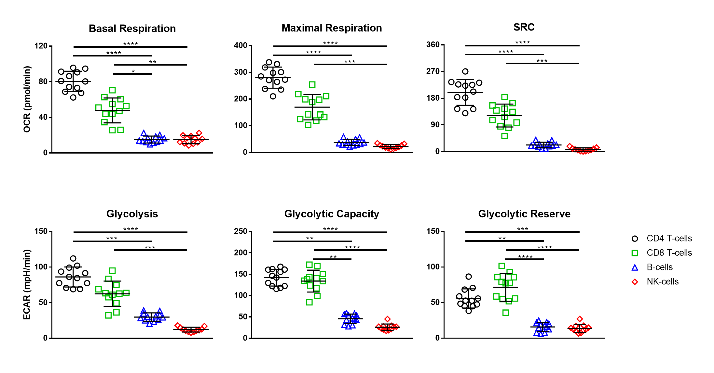

B

A

**Supplemental Figure 2**

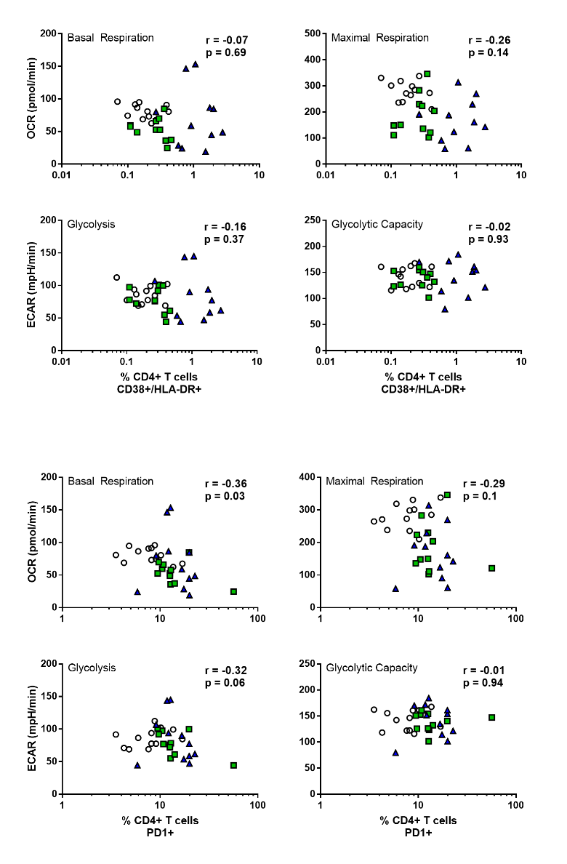

**Supplemental Figure 3**

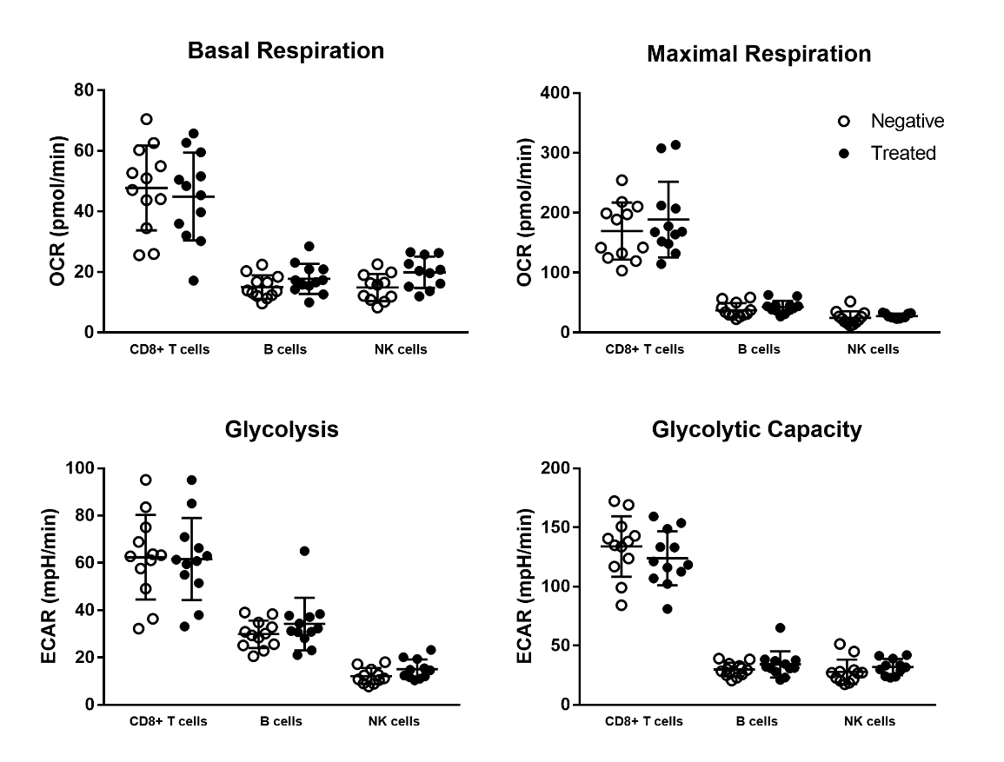

B

A

**Supplemental Figure 4**

A

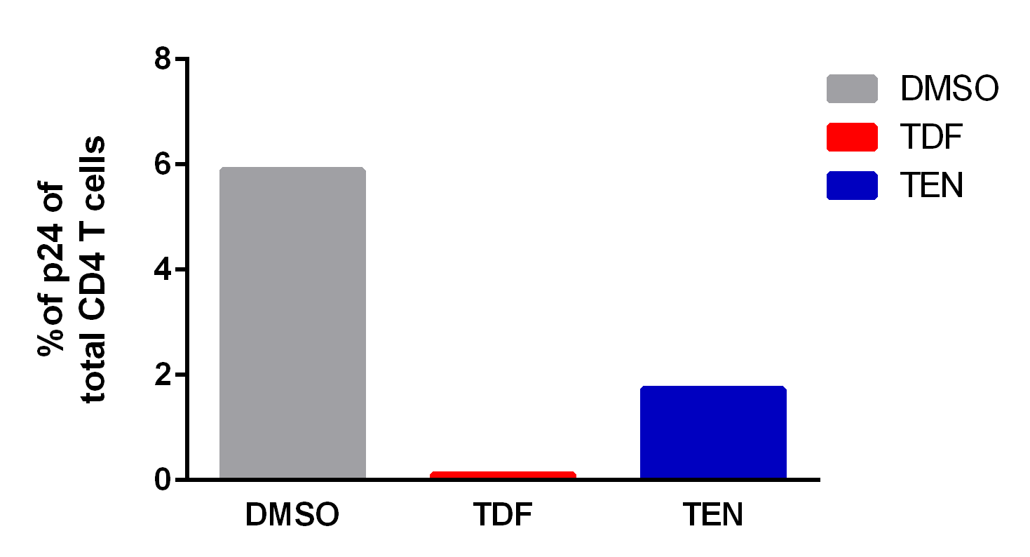

B

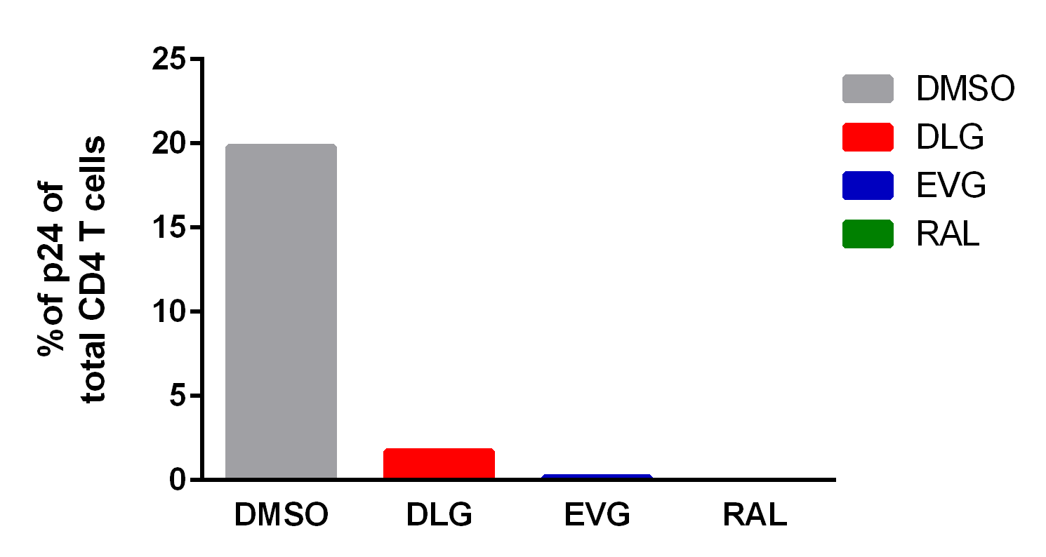

**Supplemental Figure 5**

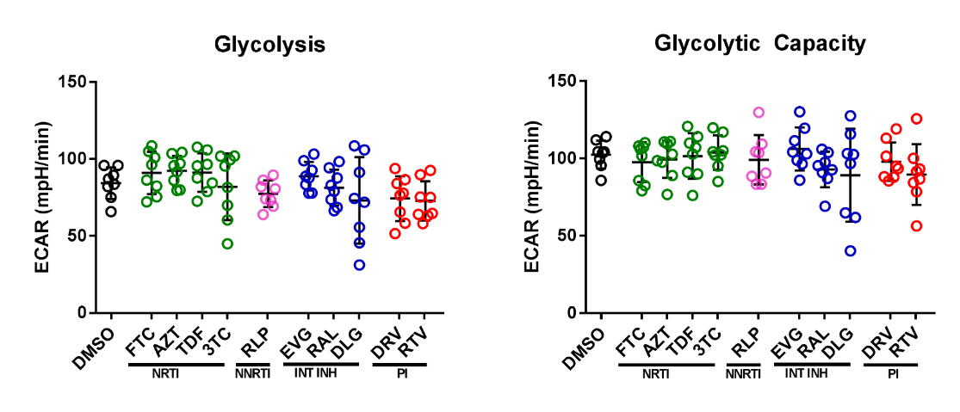

B

A

**Supplemental Figure 6**

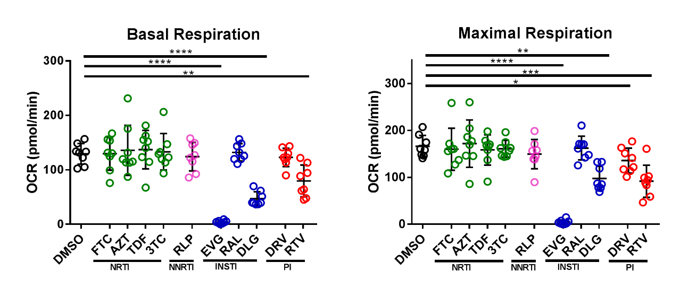

A

B

**Supplemental Figure 7**



A

B

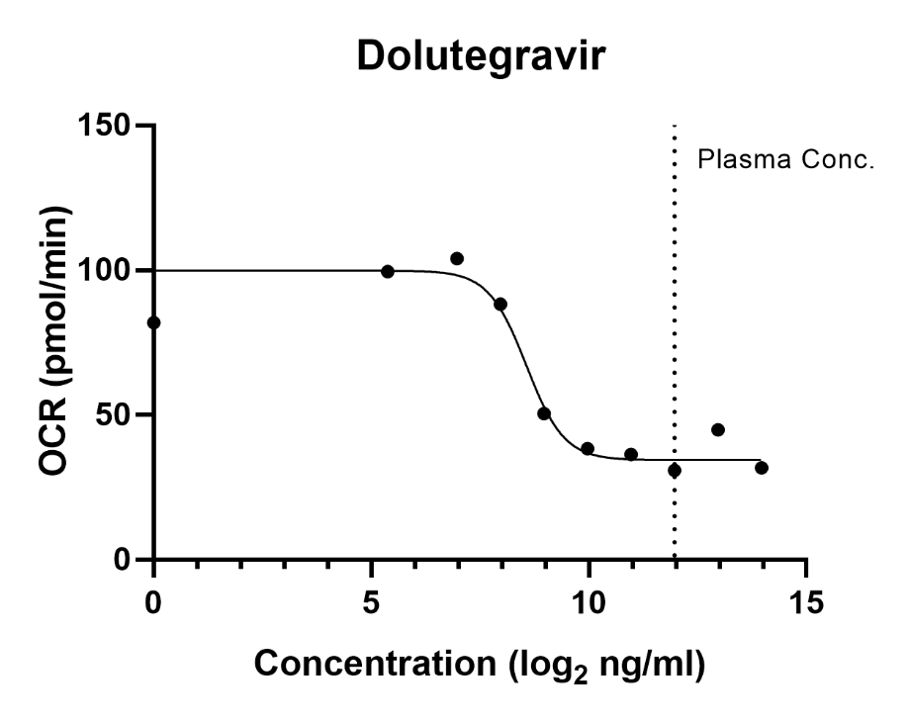**Supplemental Figure 8**

**Supplemental Figure 9**

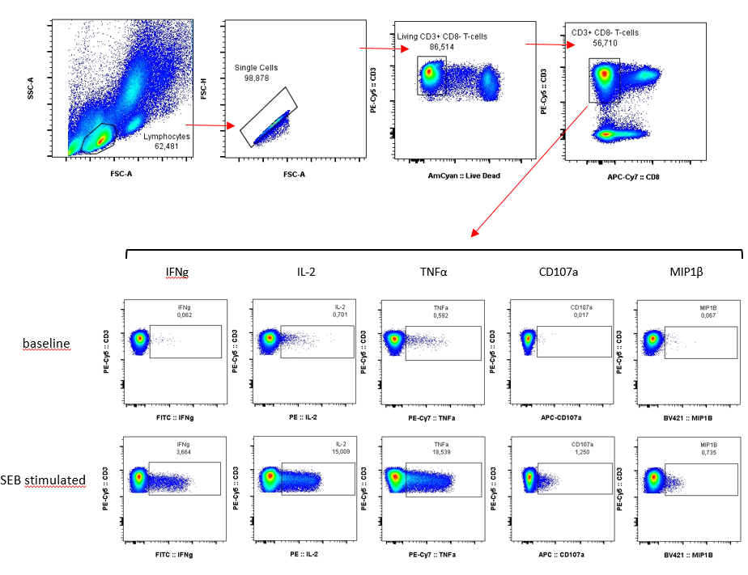

**Supplemental Table 1**

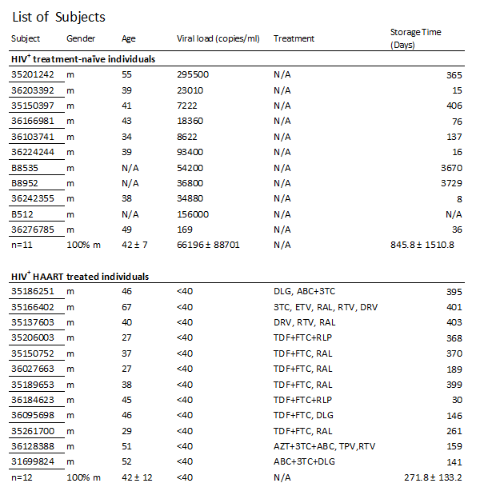

**Supplemental Table 2**

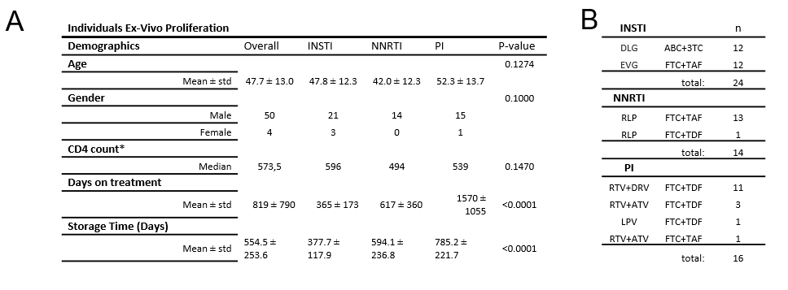

**Supplemental Table 3**

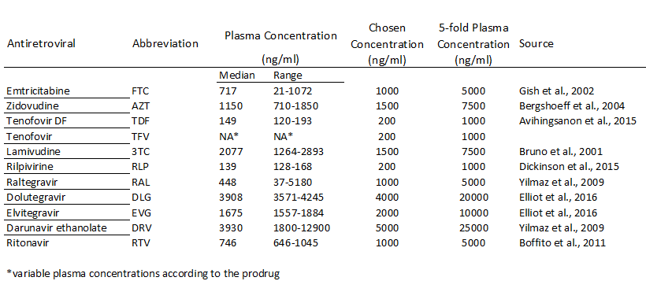

1. Gish RG, Leung NWY, Wright TL, et al. Dose Range Study of Pharmacokinetics , Safety , and Preliminary Antiviral Activity of Emtricitabine in Adults with Hepatitis B Virus Infection Dose Range Study of Pharmacokinetics , Safety , and Preliminary Antiviral Activity of Emtricitabine in Adults wi. Am Soc Microbiol 2002;46(6):1734–40.
2. Bergshoeff AS, Fraaij PLA, Verweij C, et al. Plasma levels of zidovudine twice daily compared with three times daily in six HIV-1-infected children. J Antimicrob Chemother 2004;54(6):1152–4.
3. Avihingsanon A, Sophonphan J, Thammajaruk N, et al. Plasma Tenofovir Concentrations and Proximal Tubular Dysfunction in HIV-Infected Adults Receiving Tenofovir in Thailand. J AIDS Clin Res
4. Bruno R, Regazzi MB, Ciappina V, et al. Comparison of the Plasma Pharmacokinetics of Lamivudine During Twice and Once Daily Administration in Patients with HIV. Clin Pharmacokinet 2001 ;40(9):695–700.
5. Dickinson L, Yapa HM, Jackson A, et al. Plasma Tenofovir, Emtricitabine, and Rilpivirine and Intracellular Tenofovir Diphosphate and Emtricitabine Triphosphate Pharmacokinetics following Drug Intake Cessation. Antimicrob Agents Chemother;59(10):6080–6.
6. Yilmaz A, Gisslén M, Spudich S, et al. Raltegravir cerebrospinal fluid concentrations in HIV-1 infection. PLoS One 2009;4(9):1–5.
7. Elliot E, Amara A, Jackson A, et al. Dolutegravir and elvitegravir plasma concentrations following cessation of drug intake. J Antimicrob Chemother 2016;71(4):1031–6.
8. Yilmaz A, Izadkhashti A, Price RW, et al. Darunavir Concentrations in Cerebrospinal Fluid and Blood in HIV-1 – Infected Individuals. 2009;25(4).
9. Boffito M, Jackson A, Amara A, et al. Pharmacokinetics of once-daily darunavir-ritonavir and atazanavir-ritonavir over 72 hours following drug cessation. Antimicrob Agents Chemother 2011 ;55(9):4218–23.

**Supplemental Table 4**

